**A**

**Project Report**

**ON**

**“Inventory Management”**

**Submitted**

**To**

**UDHNA CITIZEN COMMERCE COLLEGE &**

**S.P.B. COLLEGE OF BUSINESS ADMINISTRATION &**

**SMT. DIWALIBEN HARJIBHAI GONDALIA COLLEGE OF BCA AND IT**

**Affiliated**

**To**

**VEER NARMAD SOUTH GUJARAT UNIVERSITY, SURAT**

**As A Partial Fulfilment for the Degree Of**

**BACHELOR OF COMPUTER APPLICATION (B.C.A.)**

**ACADEMIC YEAR: 2019-20**

|  |  |
| --- | --- |
| **DEVELOPED BY:** | **GUIDED BY:** |
| Nityanand Jha [Seat No. –Y 209] | Chirag C. Patel |
| Alpesh Mishra [Seat No. – Y 047] |
| Saurabh Updhaya [Seat No. – Y 146] |

**:: PROJECT DEVELOPED AT::**

**UCCC & SPBCBA &SDHG COLLEGE OF BCA AND IT**

**[SURAT]**

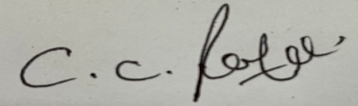

***15-04-2022***

**Inventory Management**

**Chirag Patel**

**2019038906**

**Jha Nityanand Shailendra**



**2121**

**2222**



***15-04-2022***

**2019038949**

**Alpesh Sunil Mishra**

**Inventory Management**

**Chirag Patel**



**2121**

**2222**



***15-04-2022***

**2019039047**

**Upadhyay Sauravkumar Baijnath**

**Inventory Management**

**Chirag Patel**



**2121**

**2222**

**ACKNOWLEDGEMENT**

It gives me us a great pleasure in submitting this Project entitled **“ Inventory Management ”** prepared by **NITYANAND JHA , ALPESH MISHRA, SAURABH UPDHAYA** as a part of curriculum of BCA (semester 6th).

This Project work is an integrated effort of all those, concerned through the project whose co-operative and effective guidance helped us to complete the project work.

We take this opportunity to express our profound gratitude and deep regards to our guide Assi. Pro. **Chirag C. Patel** for her exemplary guidance, monitoring and constant encouragement throughoutthe project. The blessing. Help and guidance given by her time to time shall carry us a long way in the journey of life on which we are about to embark.

We are obliged to staff members of S.D.H.G College of BCA & IT Collage, for the valuable information provided by them in their respective fields. I am grateful for their cooperation during the period of our assignment.

This was the step towards the career in IT. It was the great experience of exposing and learning new things in this field. Last but not the least we take the opportunity to thank all those people who have help directly or indirectly in making our project feasible and turn it to a successful piece of work.

Finally we would like to thanks our Parents for their support through the project. We owe to special debt to our family and friends for their support blessing and encouragement for us.

**Nityanand Jha [Seat No. –Y 209]**

**Alpesh Mishra [Seat No. – Y 047]**

**Saurabh Updhaya [Seat No. – Y 146]**

**INDEX**

|  |  |  |
| --- | --- | --- |
| **Chapter No.** | **Chapter Name** | **Page No.** |
| **1.** | **College Profile** |  |
| 1.1 Brief Overview / Highlights | 8 |
| 1.2 Institute Structure / Chart | 9 |
| **2.** | **Current / Existing System Study** |  |
| 2.1 Major Components / Flow | 10 |
| 2.2 Minimum Hardware / Software Configuration | 11 |
| 2.3 Drawbacks / Limitations | 12 |
| **3.** | **Propose Project Profile** |  |
| 3.1 Introduction | 14 |
| 3.2 Objective / Goal / Aim | 15 |
| 3.3 Scope | 16 |
| 3.4 Type of Project | 17 |
| 3.5 Technology / Environments E.g. tools | 17 |
| 3.6 Applicability of the system | 19 |
| **4.** | **Software Analysis** |  |
| 4.1 Preliminary Investigation | 20 |
| 4.2 Problem Identification | 20 |
| 4.3 Feasibility study / Risk Analysis | 21 |
| 4.3.1 Technical Feasibility | 21 |
| 4.3.2 Economical Feasibility | 21 |
| 4.3.3 Operational Feasibility | 21 |
| 4.3.4 Management Feasibility | 22 |
| 4.3.5 Time Feasibility | 22 |
| 4.4 Requirement Analysis | 22 |
| 4.4.1 Fact Finding Techniques | 22 |
| 4.4.2 Time Line Chart | 23 |
| 4.4.3 Model with Justification | 25 |
| 4.4.4 Flow Chart | 27 |
| 4.4.5 DFD and/or UML | 33 |
| 4.4.6 Process / Control Specification | 46 |
| 4.4.7 Data Dictionary | 47 |
| 4.4.8 E-R Diagram | 51 |
| 4.4.9 Data Object Description | 52 |
| **5.** | **Software Design** |  |
| 5.1 Project Design Process Hierarchy | 53 |
| 5.2 Database Design | 54 |
| 5.2.1 Justification of Normalization | 62 |
| 5.3 Architectural Design | 64 |
| 5.4 Algorithm Development / Pseudo-code | 66 |
| 5.5 User Interface Design | 67 |
| 5.6 Security Issues | 67 |
| 5.7 Quality / Reliability Measures | 67 |
| 5.8 System Map | 69 |
| **6.** | **Software Coding** |  |
| 6.1 Tools & Techniques | 71 |
| 6.2 Business Logic | 72 |
| 6.3 Result Snapshot | 102 |
| 6.4 System generated Reports |  |
| **7.** | **Software Testing** |  |
| 7.1 Test Cases & Test Data Design | 108 |
| 7.2 Output Comparison | 109 |
| 7.3 Testing Strategies | 109 |
| 7.4 Unit Testing | 110 |
| 7.5 Integration Testing | 110 |
| 7.6 System Testing | 111 |
| 7.7 Alpha Testing | 112 |
| **8.** | **Software Implementation** |  |
| 8.1 User Training | 113 |
| 8.2 User Manual | 113 |
| **9.** | **Limitations / Constraints** | 114 |
| **10.** | **Future Enhancement / Path-A-Head** | 115 |
| **11.** | **Bibliography / Appendix….. And So on…** | 116 |

**Chapter – 1. College Profile**

1.1 Brief Overview / Highlights

1.2 Institute Structure / Chart

**1.1 Brief Overview / Highlights**

**UDHNA ACADEMY EDUCATION TRUST**

Udhna Academy Education Trust was established in 1964 with the objective of catering to the educational needs of the citizens of udhna area (i.e. south zone of surat city) and south Gujarat. The Trust has completed 51 years of brilliance since inception in 1964.

It has spread the light of education in the region providing education ranging from pre-primary to Higher Secondary and Graduation.

Its pioneers started this institution with a very noble aim and far reaching vision. As a result, today, Udhna Academy Education Trust governs the following institution, where about 6000 students seek high quality education.

|  |
| --- |
| **S.D.H.G COLLEGE OF BCA & IT (B.C.A)- JUNE 2008** |
| **S.P.B COLLEGE OF BUSINESS ADMINISTRATION (B.B.A)- JUNE 2005** |
| **UDHNA CITIZEN COMMERCE COLLEGE (B.COM)- JUNE 2002** |

**COLLEGE VISION & MISSION:**

* **VISSION:**

“To be an eminent and vibrant institute for education, our credo will always be excellence through innovations, sympathy, ethics and teamwork and to cater to the ever-changing needs of community at large”.

* **MISSION:**

“To impart quality education, nature aspirations and facilities continuous learning and to contribute to the society by developing outstanding individuals who would take up leadership challenges in various sector of economy”.

**1.2 Institute / Structure Chart:**

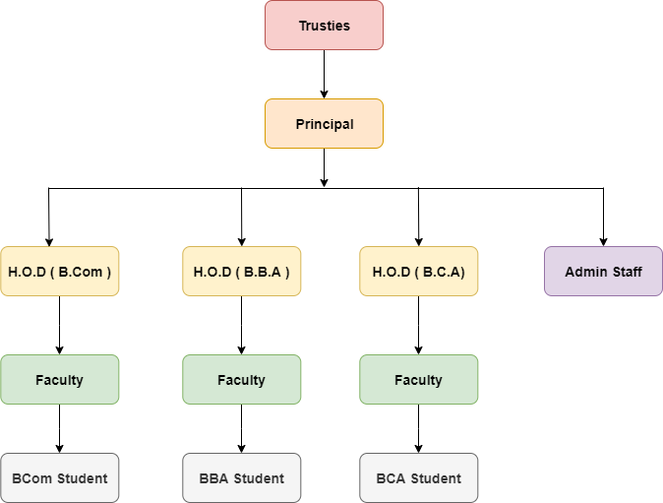

**Chapter – 2. Current / Existing System Study**

2.1 Major Components / Flow

2.2 Minimum Hardware / Software Configuration

2.3 Drawbacks / Limitations

**2.1 Major Components / Flow**

Online shopping is a form of [electronic commerce](https://en.wikipedia.org/wiki/Electronic_commerce) which allows consumers to directly buy [goods](https://en.wikipedia.org/wiki/Good_(economics)) or [services](https://en.wikipedia.org/wiki/Service_(economics)) from a seller over the [Internet](https://en.wikipedia.org/wiki/Internet) using a [web browser.](https://en.wikipedia.org/wiki/Web_browser) Consumers find a product of interest by visiting the [website](https://en.wikipedia.org/wiki/Website) of the retailer directly or by searching among alternative vendors using a [shopping search engine,](https://en.wikipedia.org/wiki/Shopping_search_engine) which displays the same product's availability and pricing at different e-retailers.

As customers can shop online using a range of different computers and devices, including [desktop computers,](https://en.wikipedia.org/wiki/Desktop_computer) [laptops,](https://en.wikipedia.org/wiki/Laptop) [tablet computers,](https://en.wikipedia.org/wiki/Tablet_computer) [smartphones,](https://en.wikipedia.org/wiki/Smartphone) and [smart speakers.](https://en.wikipedia.org/wiki/Smart_speaker)

An online store the customer to browse the firm's range of products and services, view photos or images of the products, along with information about the product specifications, features and prices. Online stores usually enable shoppers to use "search" features to find specific models, brands or items.

Online customers must have access to the Internet and a valid [method of payment](https://en.wikipedia.org/wiki/Online_shopping#Payment) in order to complete a transaction, such as a [credit card,](https://en.wikipedia.org/wiki/Credit_card) an [Interact](https://en.wikipedia.org/wiki/Interac)-enabled [debit card,](https://en.wikipedia.org/wiki/Debit_card) or a service such as [PayPal](https://en.wikipedia.org/wiki/PayPal)

* Good Experience for Mobile Shoppers
* Easy Checkout Process
* Guest Sign Ups
* Good Quality Product Photography
* Have a Clear Returns Policy
* Detailed Product Descriptions
* Clear Design & Intuitive Navigation

**2.2 Minimum Hardware / Software Configuration**

* **Hardware Requirement**

Given below is recommended hardware specification that required at client side to run software.

|  |  |
| --- | --- |
| **Processor** | I3 Processor |
| **Ram** | 6 GB RAM |
| **SDD** | 512 GB Hard Disk |

* **Software Requirement**

Given below is recommended specification of require software to develop the system.

|  |  |
| --- | --- |
| **Operating System** | Microsoft Windows 10 |
| **Front End** | Sublime Text 3.2.2 |
| **Server** | Apache, Wamp Server Version – 2.4.46 |
| **Back End** | MySQL(phpmysqladmin) |
| **Tools Used** | HTML, CSS, JavaScript, Ajax , Bootstrap, PHP, JQuery, Larval Framework |
| **Compatible Browser** | Mozilla Firefox, Google Chrome, etc. |

**2.3 Drawbacks / Limitations**

Ease of use is the prime reason that drives the success of e-commerce. Though internet provides a quick and easy way to purchase a product, some people prefer to use this technology only in a limited way. They regard internet as a means for gathering more information about a product before buying it in a shop. Some people also fear that they might get addicted to online shopping.

***The major disadvantages of online shopping are as follows.***

**1. Frauds in online shopping:**

Fraud in online shopping is the biggest disadvantage of online shopping. Many people are attracted by great offers which seem too good to be true. Fake online shopping portals display some great products on the website and attract customers to buy the product. Usually, websites which sell fake products instead of the genuine article, do not accept cash on delivery and request customers to make an online payment. But, in the end, customers will either receive the fake product or they will not receive the product at all. There are many cases of cybercrime where customers debit or credit cards details are misused to make fraudulent transactions.

**2. Delay in the delivery:**

In case of offline shopping, you can receive the product then and there. But, this does not happen in online shopping. Even though it hardly takes 10-15 minutes to buy the product online, by the time it reaches your hands, it would be more than 4-5 days. During the big sales, e-commerce portals may take too long to deliver the product.

**3. You can't touch the product:**

The sad part of online shopping is, you cannot touch the product and feel how it is. You can just see the image and read the description. Online shopping is not suitable for people who wish to buy the product only after trying it or by touching it.

**4. You cannot bargain:**

Indians are good at bargaining. You can bargain only in case of offline shopping, not in the case of online shopping. In online shopping, you get cashbacks, discounts, and coupons, but this is not the same as bargaining. Trust me if one is good at bargaining, he can save a lot of money during offline shopping.

**5. Hidden costs and shipping charges:**

When you first see the product on a portal, it generally looks cheaper. But when you proceed for the payment, the extra charges like shipping charges, tax and packing charges are added.

These charges will make the product expensive vis-a-vis the local store. Some portals offer free shipping if you shop more than a certain amount. Sometimes just to avail free shipping, you end up shopping more than your requirement.

**6. Lack of interaction:**

In case of offline shopping, sales assistants shower personal attention on customers and give complete details on the product. If you have any queries, you can ask right there. But, this does not happen in the case of online shopping. All you can do is see the picture and read the description. Some portals allow shoppers check the customer reviews.

**7. Returning the product:**

There is an option to return the product, if you do not like it. But again, it is a big headache. The return policy differs from one company to other. In case of some online shopping portals, customers have to bear the cost of returning the product. If you return the product, you will not be paid shipping charges which you had paid earlier. If you are shopping for cosmetics like a lipstick, they can't be returned.

**8. Low Level of Security:**

In our current system all the work that is done is carried out on the register and so there are security criteria to guard our data and any person can open data and any person can open register and make changes and may affect our reports. In this, it is quite open to everybody.

**9.** **Time Consuming:**

In our current system, all the process are carried out by human so naturally it require more time and in that sense, it will require more time to complete transaction.

**Chapter – 3. Propose Project Profile**

3.1 Introduction

3.2 Objective / Goal / Aim

3.3 Scope

3.4 Type of Project

3.5 Technology / Environment E.g. tools

3.6 Applicability of the system

**3.1 Introduction**

Anything that customer’s purchases affects environment by means of delivery, whether they have the product shipped at home or drive to a brick and mortar store (supermarket). In earlier days people used to go to different shops before purchasing as they didn’t have a great deal of easy access to information on products.

Due to the development of World Wide Web it has now become easy to access the products available worldwide without wasting time, money and other resources apart from helping environment. Centre for Energy and Climate Solutions suggests that we can protect land and save energy by shopping online.

The example of Octavo Group plc that delivers the grocery directly to the customer instead of shopping from the supermarket helped in controlling the carbon emissions.

Many supermarkets such as Marks and Spencer’s, John Lewis, Amazon, Carbon Cart etc. have their own websites are selling greener products and offering more choices to customers.

Octavo’s mission is to revolutionise the way people shop by giving them innovative and greener alternatives to traditional shopping. Using the cutting edge technology in their delivery model helps them to cut price, deliver quality and save environment.

“Meat free Mondays” creates environmental awareness of climate changing impact of production of meat and consumption. By using bio- diesel in delivery vans the emission is reduced.

They deliver their products from the state-of-the-art warehouses directly to consumer home.

They are using anaerobic digestion to produce electricity from the leftover food. The company has their own green team called eco-warriors to increase environment awareness amongst the staff. They have slots allotted for green van area-wise to reduce carbon emission.

They use combined heat and power (CHP) which is energy efficient process to mitigate environmental impact. A lot of recycling works using closed loop grocery bag recycling by keeping a track of the consumption of plastic bags and batteries.

**3.2 Objective / Goal / Aim**

**1. Service or product advertising**

The main purpose of a business site is to promote company’s products, services or events on the Internet. There are two main aspects to discuss. First, there are websites that don’t directly sell anything but their objective is to create “buzz” or awareness. An example would be, let’s say an event - a trance music performance taking place next month. The purpose of the site is to generate interest so the people will attend the show. This kind of website might contain recorded presentations from previous shows, images with the performers, more details on the performance, etc…

Secondly, there are websites that both promote and sell products or services and this aspect is discussed below.

**2. Selling a product or a service online**

This is basically the main reason behind the existence of any business website. Selling products and services is the most common objective. You have to provide full and comprehensive information on what you sell, allowing prospective customers to easily order from your site. The information must refer to:

* Features of the product or service
* Payment methods
* Return policies
* Warranties
* Shipping options
* Product or service F.A.Q.

If you sell directly from your website, you must consider additional security issues (example: SSL encrypted connections - https), and to address them in an adequate manner for a safe and pleasant user experience.

**3. Providing product support and customer service**

Due to its wold-wide nature, the Internet is a flexible structure allowing users to choose from thousands of similar products they are just one click away. What actually makes the difference between similar online businesses are the price and the customer support they provide. Top companies usually have outstanding customer services and assistance 24 hours a day, 7 days a week, and 365 days a year.

Not only the customer service is important to provide support to actual customers but it can generate sales while communicating with prospective clients, answering their questions and offering all the necessary information they need. By offering your clients the possibility to solve their problems in an easy way, you increase loyalty of actual customers and build a solid base of prospective customers - so placing a new order is just a matter of time.

**4. Providing corporate information**

Almost all big company websites have a section featuring pertinent corporate information for potential investors. The information in this section usually refers to: corporate background, company officials, different articles and editorials written about the company along with related images as well as contact information and links to personal profiles of company’s representatives charged with management, customer care, advertising, etc…

**5. Establishing brand awareness and identity**

Establishing brand awareness or company identity is an ongoing process with the purpose of branding products with memorable names, eye-catching logos and maybe a slogan. In order to establish brand identity, your website must address these elements in a unitary manner. The product logo must reflect the design of your website in terms of graphics, colours, font types and sizes (example: Coca Cola website). The slogan must be unique, original and appealing so the customers easily remember it. All these elements contribute to establishing a strong brand identity.

**3.3 Scope**

* **Admin Side:-**
* Maintain Product details
* Unlimited Product Upload
* Maintain Customer details
* Maintain Dealer details
* Flexibility to Manage Sales
* Maintain Order
* Easy Customer Management
* **Client Side:-**
* User can login
* User can book Product
* User can register
* User Can Check Order Details
* User Can Manage Profile
* User Can Buy Product
* User Can Check Out
* User can check about us page
* User can check contact us page
* Logout

**3.4 Type of Project**

The project type of this system is renting the Online Shopping system is fully web based website.

This system is full web based Online Shopping system.

* Developed by the help of Visual Studio Code
* Visual Studio Code Web Developer is a full-featured development environment for creating php web sites.
* ***Visual Studio Code Web Developer offers you the following features***:
* Page design features Consistent site layout with master pages and consistent page appearance with themes and skins.
* Code editing a code editor that enables you to write for the dynamic web pages inVisual Studio Code Basic.
* Testing and Debugging. A local Web server for testing and a debugger that helps you find errors in your programs.
* Development Tools to automate typical tasks for deploying a Web application to a hosting server or a hosting provide

**3.5 Technology / Environments E.g. tools**

In each and every system there is a need of two different ends to handle the system. Each System requires the main Platform perform all tasks that will appear in system and these tasks will be performed by only Front End.

The main need of taking front end is that all programming that will be perform according to the environment and facility by the opted front end and taking back end is that all database are kept in that base.

* **Hardware specification:**

**Development Time:** Minimum 4 GB Ram, Dual Core or Higher Processor.

**Run Time:** Minimum 1 GB Ram, Dual Core or Higher Processor.

* **Software Specification:**

**Front End** **:** Visual Studio Code

**Server** **:** Apache, Wamp Server Version 2.74.46

**Back End** **:** MySQL (phpmysqladmin)

* **Other Tools:** Java Script, Ajax, cascading style sheet, HTML, JQuery.
* **Java script:-**
  + JavaScript is an object-based scripting language.
  + Giving the user more control over the browser.
  + It Handling dates and time.
  + It detecting the user's browser and OS,
  + It is light weighted.
  + JavaScript is a scripting language and it is not java.
  + JavaScript is interpreter based scripting language.
  + JavaScript is case sensitive.
  + JavaScript is object based language as it provides predefined objects.
  + Every statement in JavaScript must be terminated with semicolon (;).
  + Most of the JavaScript control statements syntax is same as syntax of control Statements in C language.
  + An important part of JavaScript is the ability to create new functions within scripts. Declare a function in JavaScript using function keyword.
* **AJAX :-**
* AJAX is not a new programming language , but a technique for creating better, faster, and more interactive web applications
* AJAX , which consists of HTML , JavaScript technology , DHTML , and DOM , is an outstanding approach that helps you transform clunky web interfaces into interactive AJAX applications
* The AJAX technique makes Internet applications smaller , faster and more user-friendly
* AJAX is a browser technology independent of web Server Software.
* **Cascade Style Sheets:-**

The latest version of Cascade Style Sheets, CSS 3, was developed to make Web design easier but it became a hot topic for a while because not all browsers supported it. However, trends change quickly in technology and all browser makers currently are implementing complete CSS 3 support.

Making that process easier for the browser manufacturers is CSS 3's modularized specification, which allows them to provide support for modules incrementally without having to perform major refactoring of the browsers' codebases. The modularization concept not only makes the process of approving individual CSS 3 modules easier and faster, but it also makes documenting the spec easier.

* **HTML**
* HTML stands for Hyper Text Mark-up Language
* HTML describes the structure of a Web page
* HTML consists of a series of elements
* HTML elements tell the browser how to display the content
* HTML elements are represented by tags
* HTML tags label pieces of content such as "heading", "paragraph", "table", and so on
* Browsers do not display the HTML tags, but use them to render the content of the page.
* **JQuery:-**

JQuery is a JavaScript library that allows web developers to add extra functionality to their websites. It is open source and provided for free under the MIT license. In recent years, jQuery has become the most popular JavaScript library used in web development.

To implement jQuery, a web developer simply needs to reference the jQuery JavaScript file within the HTML of a webpage. Some websites host their own local copy of jQuery, while others simply reference the library hosted by Google or the jQuery server.

* Effects and animations.
* Ajax.
* Extensibility.
* DOM element selections functions.
* Events.
* CSS manipulation.
* Utilities - such as browser version and the each
* Function.
* JavaScript Plugins.
* DOM traversal and modification

**3.6 Applicability of the system**

Viewing available car at the website can be done for which client have to go to the website and check the available cars.

**Chapter – 4. Software Analysis**

4.1 Preliminary Investigation

4.2 Problem Identification

4.3 Feasibility Study / Risk Analysis

4.4 Requirement Analysis

**4.1 Preliminary Investigation**

In our case as we were developing commerce web site it converted answered to questions like

1. What is the basic functionality of Commerce site website?
2. How you can establish communication?
3. How automated do you want the application to be?
4. What kind of functionality to be developed to make system easy to use on both owner and Admin side?
5. How can we build attractive site so that more and more users can use this website?

**4.2 Problem Identification**

* **Definition of the Problem:**

To create or develop new system first we have to study the prior system, analysis difficult problem faced by the operator of that system. System analysis therefore understands such problems and proposes a new system in which the above problems are rectified.

* **Existing system:**

Before creating this website, all clients have to register through postal mails or they use person to person contacts with each other.

Here there May error occurs in the process. The administration faces the problems to collect all the information from clients. And consults to analyse the requirement in the corresponding client. Administration has to send cars information different consultants and clients.

**4.3 Feasibility study / Risk Analysis**

The main purpose of feasibility analysis is to check the economic viability of the purpose system. The result of the feasibility study will indicate whether to proceed with the proposed system or not. If the results of the feasibility study are positive then we can proceed to develop a system otherwise the project should not be perused.

**4.3.1 Technical Feasibility**

The technical issue usually raised during the feasibility stage of the investigation includes the following:-

* Does the necessary technology exists to do what is suggested?
* Do the proposed equipment’s have the technical capacity to hold the data required to use the new system?
* Will the proposed system provide adequate response to inquiries, regardless of the number of locations of users?
* Can the system be upgraded if developed?
* Are there technical guarantees of accuracy, reliability ease of access and data security?

**4.3.2 Economical feasibility**

Proposed system requires development tools and software such as Sublime Text 3.2.2

Ultimate, for developing purpose system, we need various resources such as computer systems, internet connection for e-help, recommended disk space and memory speed as mentioned in technical requirement.

***We have many benefits from proposed system such are***

* As existing system is manual, where data may not accurate, up-to-date available on time. But proposed will be computerized, so we can overcome all limitations of existing system.
* This system will reduce the paperwork .and quality of data will be improved.*

**4.3.3 Operational Feasibility**

Users of the system will be registered as a user of the website by the TPO department of the college. to put an orders user should have basic knowledge of the computer . And internet which is not be big issue. Basic training is required for other users to handle and manage the information.

**4.3.4 Management Feasibility**

Management feasibility is not comes in basic feasibility of system, but it’s arise and aspects of management use. Here all level of management revise all related basic feasibilities and know the requiredness of that all, after that all manager gives their decision for those feasibility to use or not.

**4.3.5 Time Feasibility**

Time feasibility describes the time cost for converting the present system to new system.

As an aspect of time feasibility our system takes 3 months for completion. This system is developed under the time period of just 3 month. So we can say that this system is time feasible.

**4.4 Requirement Analysis**

Requirement analysis can be said to identify investigation, documenting and analysing requirements of the system. The first investigation step of the need of a system is a major activity of problem analysis.

This is the role of a system analyst to determine the actual requirement of a system. Sometimes, system analyst may make mistake in discovering the requirements and in trying to analyse a problem.

As a result, they may come up with the wrong solution in designing and implementation of a solution.

And the solution will not be able to solve the real problem and even cause a new problem in later system analysis process. Therefore, this paper looks at one of the effective methods (fact-finding) for system analyst to help them in gathering information.

**4.4.1 Fact Finding Techniques**

**Definition of Fact-finding Techniques**

Fact finding is process of collection of data and information based on techniques which contain sampling of existing documents, research, observation, prototyping and joint requirements planning.

System analyst uses suitable fact-finding techniques to develop and implement the current existing system.

Collecting required facts are very important to apply tools in System Development Life Cycle because tools cannot be used efficiently and effectively without proper extracting from facts.

Fact-finding techniques are used in the early stage of System Development Life Cycle including system analysis phase, design and post implementation review.

Facts included in any information system can be tested based on three steps: data- facts used to create useful information, process-functions to perform the objectives and interface- designs to interact with users.

**Fact-finding techniques Features**

* There are seven common fact-finding techniques
* Sampling of existing documentation, forms and databases
* Research and Site visits
* Observation of the work environment
* Prototyping
* Joint requirements planning
* Information gathering in any organization is not an easy task.
* it has to be gathered in an organized way so that
  1. No system details are left out.
  2. Right problems are identified.
  3. Repetitive work is avoided.
  4. Wrong or incomplete details are not collected.
* To do this, a proper search strategy must be decided first, search strategy includes selecting information sources and search methods.
* Here an overall idea about the search methods or fact gathering techniques which are used while gathering the information, they are:

**4.4.2 Time Line Chart**

**Table 4.1: Time Line Chart**

|  |  |  |  |  |  |  |  |  |  |  |  |  |  |  |  |  |  |  |  |  |  |
| --- | --- | --- | --- | --- | --- | --- | --- | --- | --- | --- | --- | --- | --- | --- | --- | --- | --- | --- | --- | --- | --- |
| **Sr. No.** | **Work** | **DEC** | | **JANUARY** | | | | **FEBRUARY** | | | | | **MARCH** | | | | | **APR** | | | |
| **Week =======================🡺** | | **3** | **4** | **1** | **2** | **3** | **4** | **1** | **2** | **3** | **4** | **1** | | **2** | **3** | **4** | **1** | | **2** | **3** |
|  | | | | | | | | | | | | | | | | | | | | | |
| **1.** | **Requirement Gathering & Analysis** | | | |
| 1.1 Learn php |  |  |  |  |  |  |  |  |  |  |  | |  |  |  |  | |  |  |
| 1.2 Requirement Gathering |  |  |  |  |  |  |  |  |  |  |  | |  |  |  |  | |  |  |
| 1.3 Requirement Analysis |  |  |  |  |  |  |  |  |  |  |  | |  |  |  |  | |  |  |
| 1.4 Search for Template |  |  |  |  |  |  |  |  |  |  |  | |  |  |  |  | |  |  |
| **Milestone:** Requirements Gathered. | | | | | | | | | | | | | | | | | | | | |
| **2.** | **Modelling** | | | | | | | | | | | | | | | | | | | | |
| 2.1 Identifying proposed project profile. |  |  |  |  |  |  |  |  |  |  |  | |  |  |  |  | |  |  |
| 2.2 Identifying Objectives. |  |  |  |  |  |  |  |  |  |  |  | |  |  |  |  | |  |  |
| 2.3 Scope definition. |  |  |  |  |  |  |  |  |  |  |  | |  |  |  |  | |  |  |
| 2.4 Review. |  |  |  |  |  |  |  |  |  |  |  | |  |  |  |  | |  |  |
| **Milestone:** Modelling Completed. | | | | | | | | | | | | | | | | | | | |
| **3.** | **System Design** | | | | | | | | | | | | | | | | | | | | |
| 3.1 Design system flow. |  |  |  |  |  |  |  |  |  |  |  | |  |  |  |  | |  |  |
| 3.2 Database Design |  |  |  |  |  |  |  |  |  |  |  | |  |  |  |  | |  |  |
| 3.3 Admin Side Design. |  |  |  |  |  |  |  |  |  |  |  | |  |  |  |  | |  |  |
| 3.4 Client Side Design |  |  |  |  |  |  |  |  |  |  |  | |  |  |  |  | |  |  |
| 3.5 Driver Side Design |  |  |  |  |  |  |  |  |  |  |  | |  |  |  |  | |  |  |
| 3.6 Review |  |  |  |  |  |  |  |  |  |  |  | |  |  |  |  | |  |  |
| **Milestone:** System Design completed | | | | | | | | | | | | | | | | | | | | |
| **4.** | **Coding** | | | | | | | | | | | | | | | | | | | | |
| 4.1 Admin Side Coding |  |  |  |  |  |  |  |  |  |  |  | |  |  |  |  | |  |  |
| 4.2 Client Side Coding |  |  |  |  |  |  |  |  |  |  |  | |  |  |  |  | |  |  |
| 4.3 Driver side coding |  |  |  |  |  |  |  |  |  |  |  | |  |  |  |  | |  |  |
|  | **Milestone:** Coding completed | | | | | | | | | | | | | | | | | | | |
| **5.** | **Testing** | | | | | | | | | | | | | | | | | | | | |
| 5.1 Unit testing |  |  |  |  |  |  |  |  |  |  |  | |  |  |  |  | |  |  |
| 5.2 Integration Testing |  |  |  |  |  |  |  |  |  |  |  | |  |  |  |  | |  |  |
| 5.3 Correction |  |  |  |  |  |  |  |  |  |  |  | |  |  |  |  | |  |  |
| **Milestone:** Testing Complete | | | | | | | | | | | | | | | | | | | |
| **6.** | **Documentation** |  |  |  |  |  |  |  |  |  |  |  | |  |  |  |  | |  |  |

**4.4.3 Model with Justification**

It was agreed that the Web interface should be implemented in accordance with software engineering best practise. Software engineering requires the application of a disciplined approach to the software development process.

These constraints impose stability and order in an environment that can otherwise become chaotic (Pressman, 2000). Wherever possible, these activities are constrained further by the use of tools such as source code version control software.

**Prototype Model**

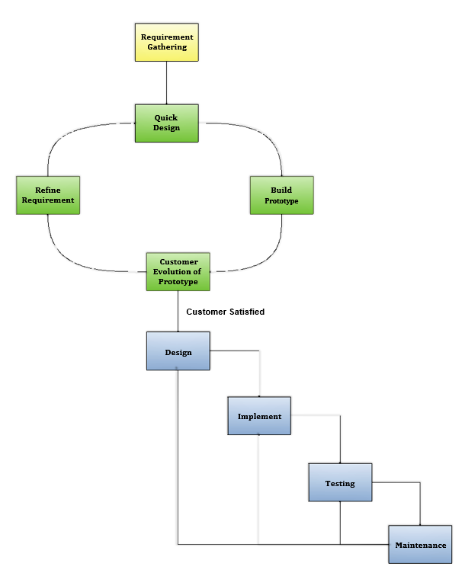

The Prototyping Model is one of the most popularly used Software Development Life Cycle Models (SDLC models).This model is used when the customers do not know the exact project requirements beforehand.

In this model, a prototype of the end product is first developed, tested and refined as per customer feedback repeatedly till a final acceptable prototype is achieved which forms the basis for Developing the final product.

**Step 1: Requirements gathering and analysis**

A prototyping model starts with requirement analysis. In this phase, the requirements of the system are defined in detail. During the process, the users of the system are interviewed to know what their expectation from the system is.

**Step 2: Quick design**

The second phase is a preliminary design or a quick design. In this stage, a simple design of the system is created. However, it is not a complete design. It gives a brief idea of the system to the user. The quick design helps in developing the prototype.

**Step 3: Build a Prototype**

In this phase, an actual prototype is designed based on the information gathered from quick design. It is a small working model of the required system.

**Step 4: Initial user evaluation**

In this stage, the proposed system is presented to the client for an initial evaluation. It helps to find out the strength and weakness of the working model. Comment and suggestion are collected from the customer and provided to the developer.

**Step 5: Refining prototype**

If the user is not happy with the current prototype, you need to refine the prototype according to the user's feedback and suggestions.

This phase will not over until all the requirements specified by the user are met. Once the user is satisfied with the developed prototype, a final system is developed based on the approved final prototype.

**Step 6: Implement Product and Maintain**

Once the final system is developed based on the final prototype, it is thoroughly tested and deployed to production. The system undergoes routine maintenance for minimizing downtime and prevent large-scale failures.

* **Advantages of Prototype model**
* This model is flexible in design.
* It is easy to detect errors.
* We can find missing functionality easily.
* There is scope of refinement, it means new requirements can be easily accommodated.
* It can be reused by the developer for more complicated projects in the future.
* It ensures a greater level of customer satisfaction and comfort.
* It is ideal for online system.
* It helps developers and users both understand the system better.
* Integration requirements are very well understood and deployment channels are decided at a very early stage.
* It can actively involve users in the development phase.
* **Disadvantages of Prototype Model**
* This model is costly.
* It has poor documentation because of continuously changing customer requirements.
* There may be too much variation in requirements.
* Customers sometimes demand the actual product to be delivered soon after seeing an early prototype.
* There may be sub-optimal solutions because of developers in a hurry to build prototypes.
* Customers may not be satisfied or interested in the product after seeing the initial prototype.
* There is certainty in determining the number of iterations.
* There may be incomplete or inadequate problem analysis.
* There may increase the complexity of the system.

**4.4.4 Flow Chart**

A pictorial representation of an algorithm is called a „Flowchart‟. In flowchart, the steps in the algorithm are represented in the form of different shapes of boxes and the logical flow is indicated by interconnecting arrows. The boxes are used to represent different operations and the arrows are used to represent the sequence of these operations. Since this is a visual way of algorithm representation, it helps the programmer/tester in understanding the logic of the program.

**Symbols Used In Flowchart**

Different symbols are used for different states in flowchart, for example: Input/output and decision making has different symbols. The table below describes all the symbols that are used in making flowchart

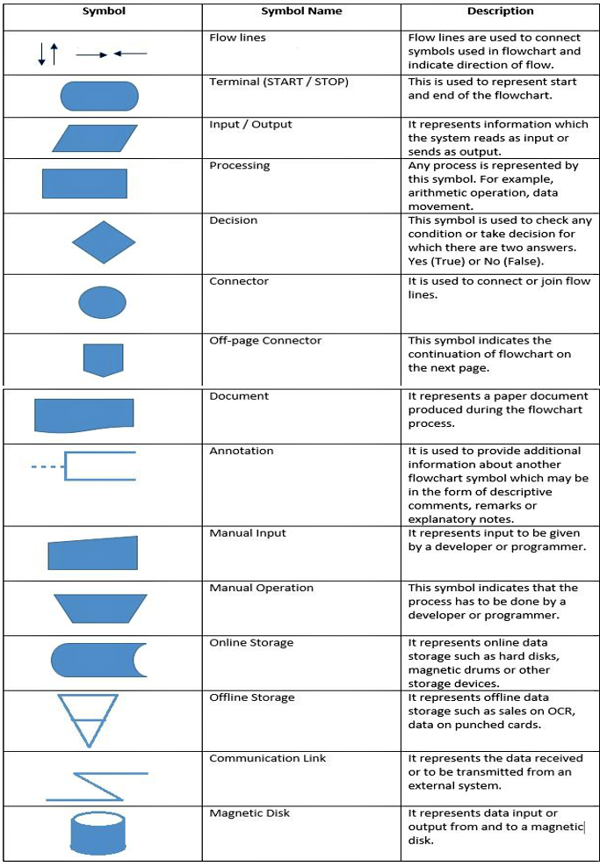

**Figure 4.2 Flowchart Symbols**

**1. Flow Chart for Login Process**

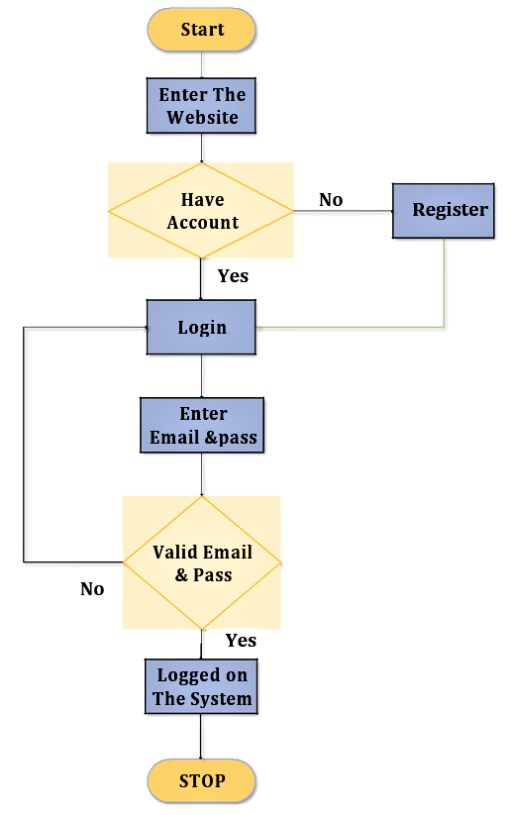

**Figure 4.3 Flowchart Login Process**

**2. Flowchart for Registration Process**

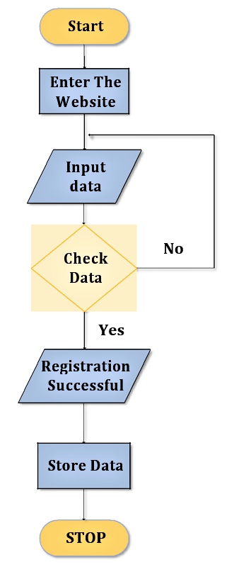

**Figure 4.4 Flowchart Registration Process**

**3. Flowchart for Admin Side Process**

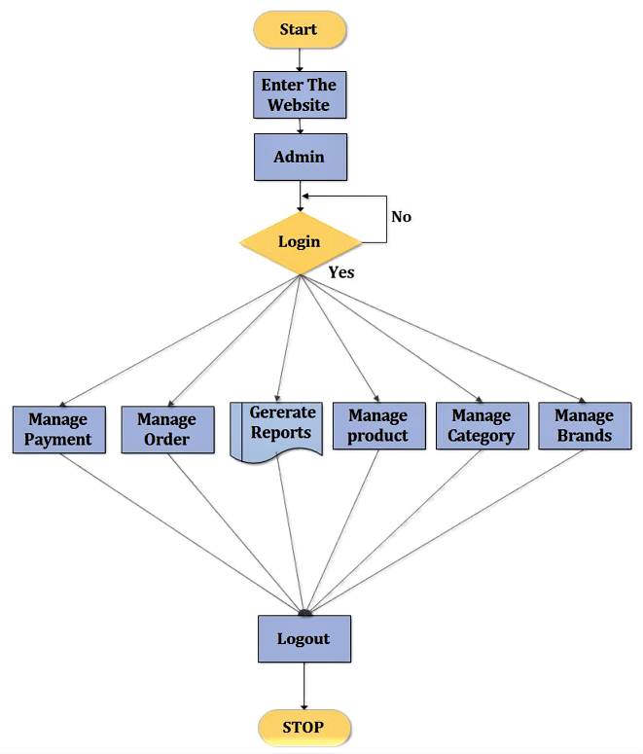

**Figure 4.5 Flowchart Admin Side**

**4. Flowchart for User Side Process**

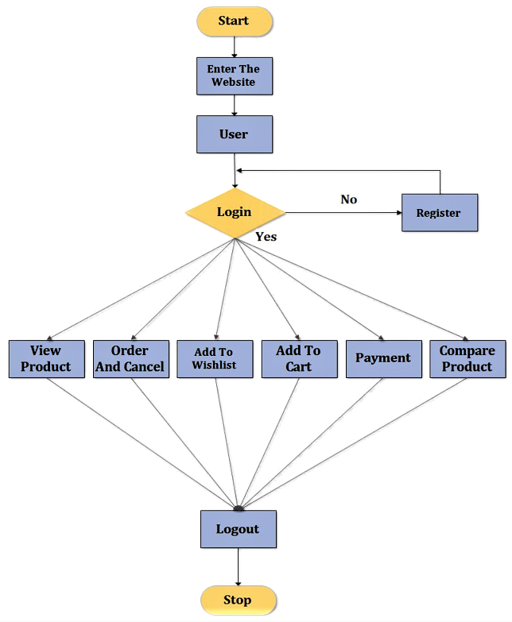

**Figure 4.6 Flowchart User Side**

**4.4.5 Data Flow Diagram (DFD)**

A data flow diagram is a graphical view of how data is processed in a system in terms of input and output.

The Data flow diagram (DFD) contains some symbol for drawing the data flow diagram.

**Data flow diagram symbol:**

**Table 4.2 Data Flow Diagram Symbol**

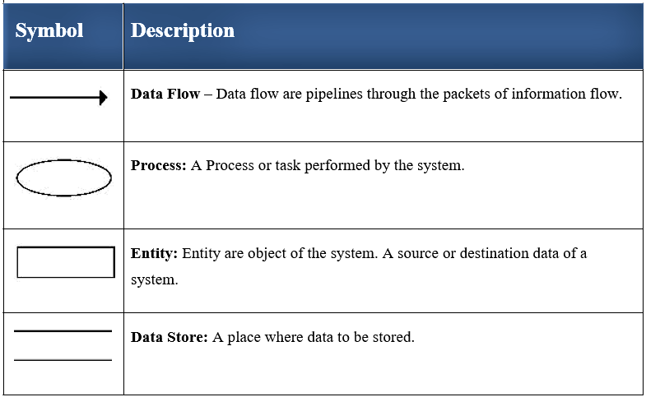

**1. Zero Level Data Flow Diagram (Context Level)**

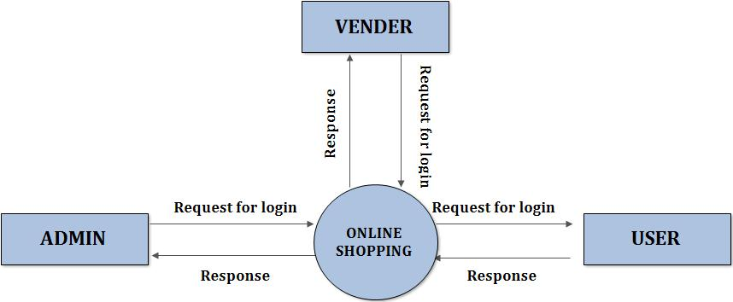

**Figure 4.8 Zero Level Data Flow Diagram**

**2. First Level Admin Side Data Flow Diagram**

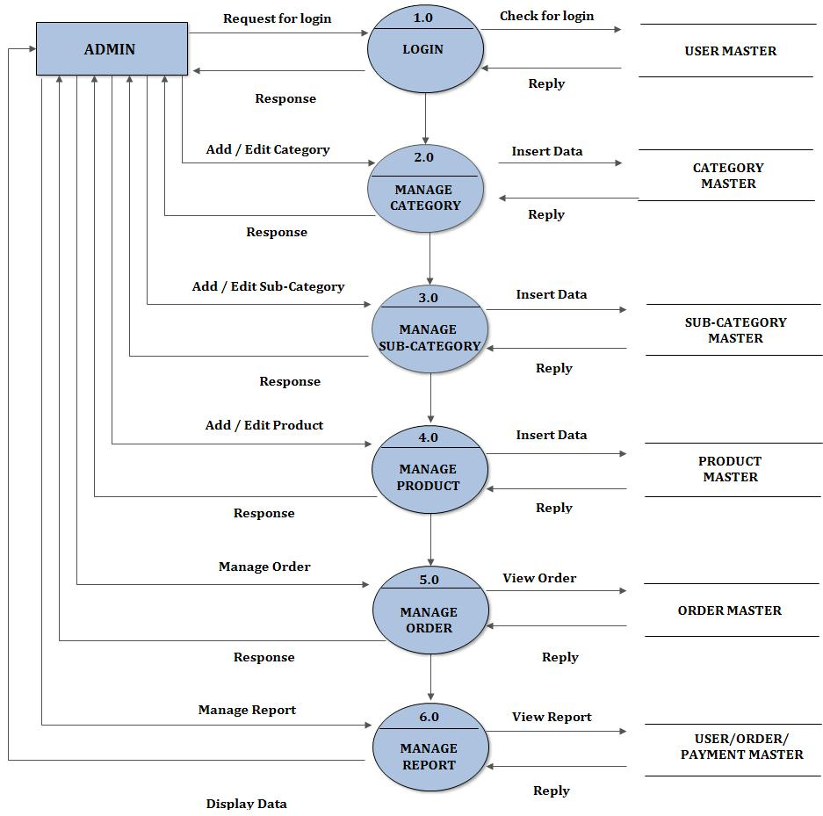

**Figure 4.9 First Level Admin Side Data Flow Diagram**

**3. Second Level Admin Side Data Flow Diagram (2.0)**

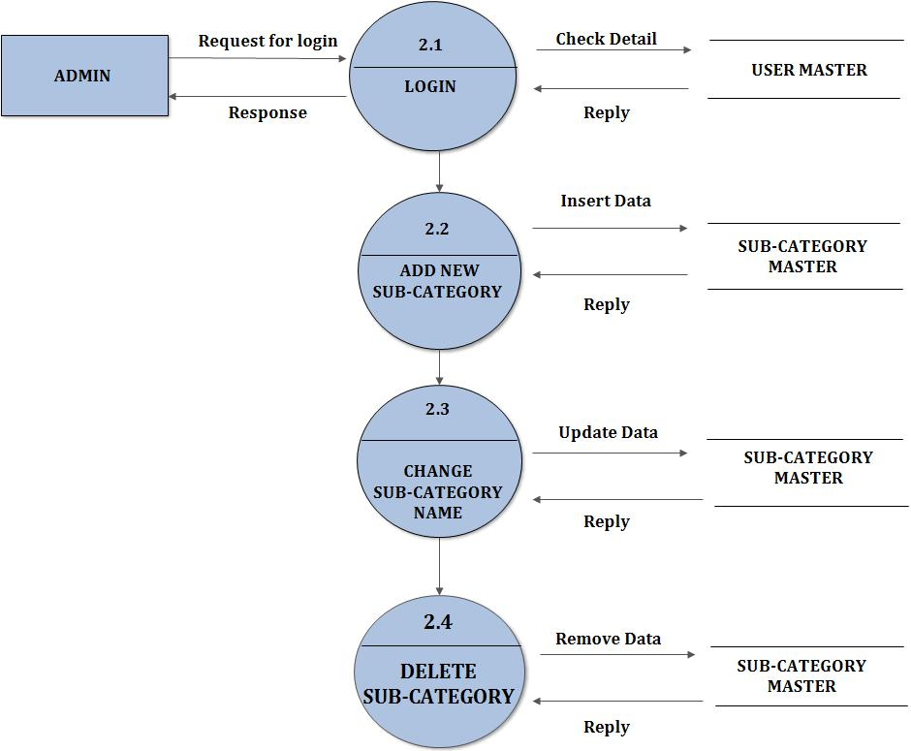

**Figure 4.10 Second Level Admin Side Data Flow Diagram (2.0)**

**4. Second Level Admin Side Data Flow Diagram (3.0)**

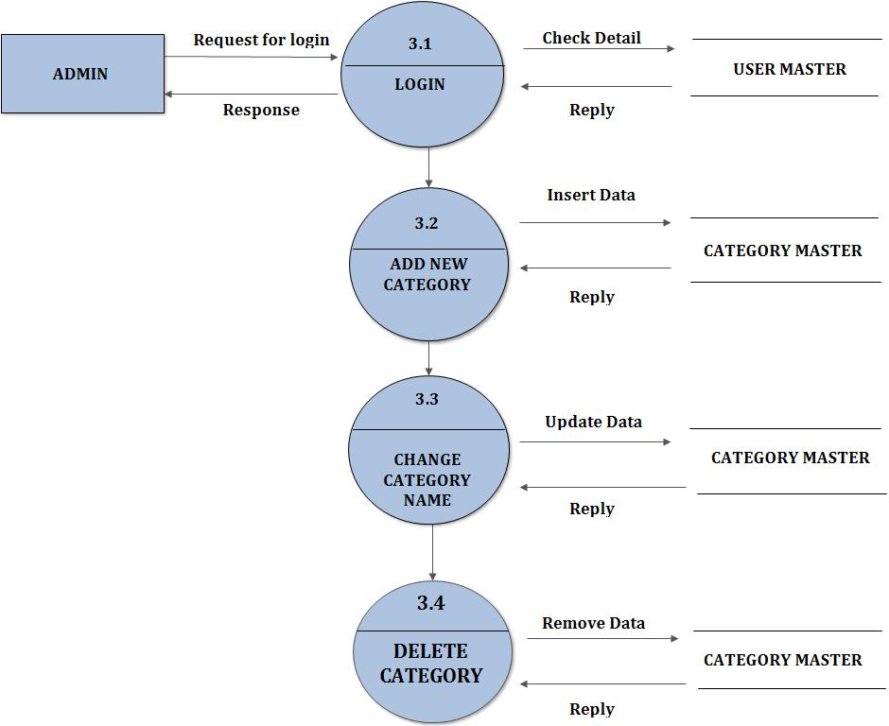

**Figure 4.11 Second Level Admin Side Data Flow Diagram (3.0)**

**5. Second Level Admin Side Data Flow Diagram (4.0)**

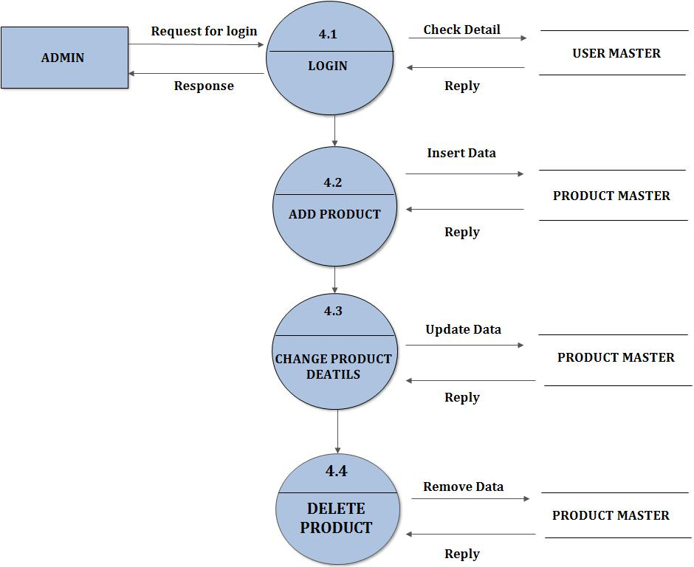

**Figure 4.12 Second Level Admin Side Data Flow Diagram (4.0)**

**6. Second Level Admin Side Data Flow Diagram (5.0)**

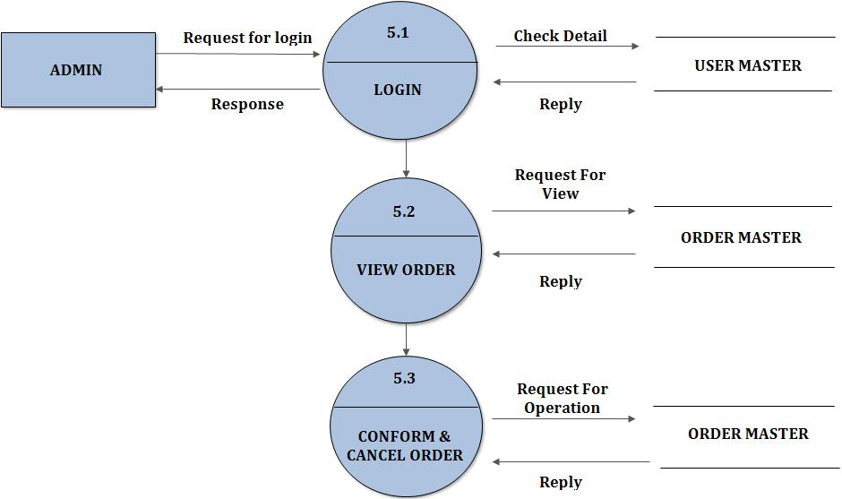

**Figure 4.13 Second Level Admin Side Data Flow Diagram (5.0)**

**7. Second Level Admin Side Data Flow Diagram (6.0)**

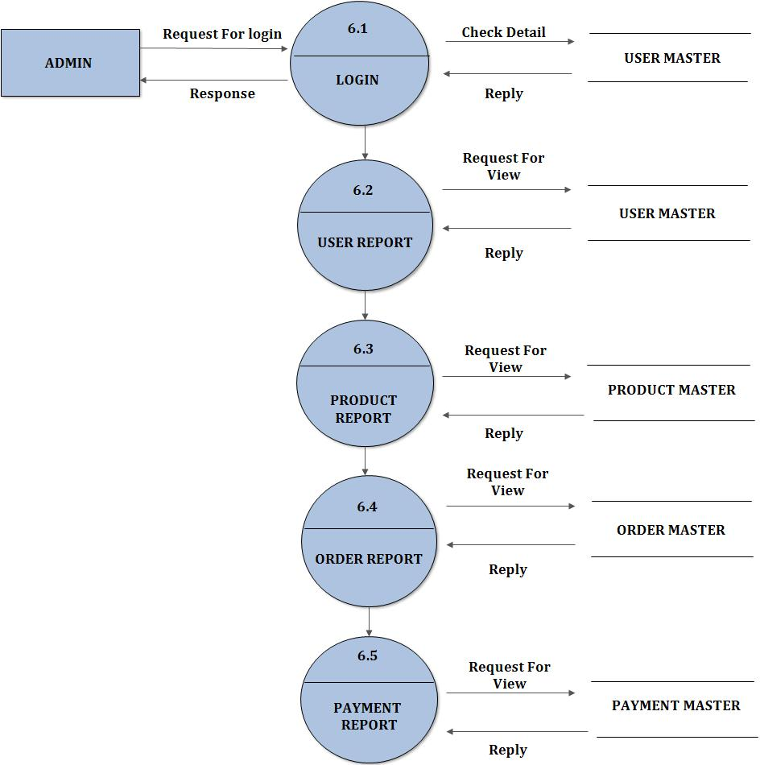

**Figure 4.14 Second Level Admin Side Data Flow Diagram (6.0)**

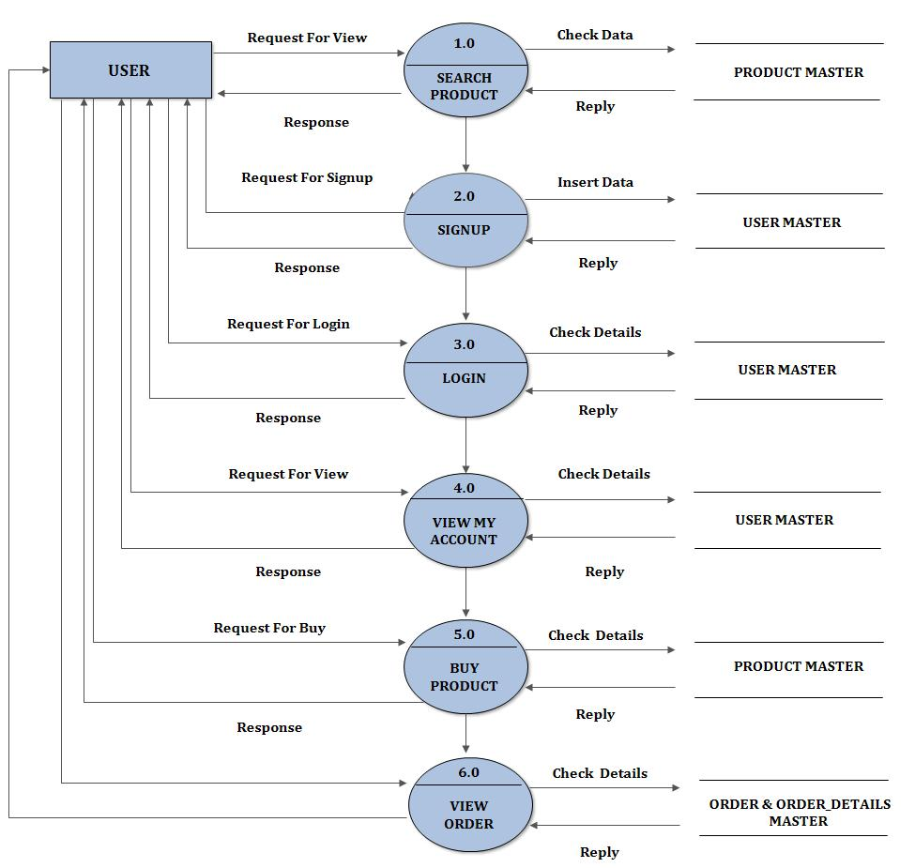**8. First Level User Side Data Flow Diagram**

**Figure 4.15 First Level User Side Data Flow Diagram**

**9. Second Level User Side Data Flow Diagram (2.0)**

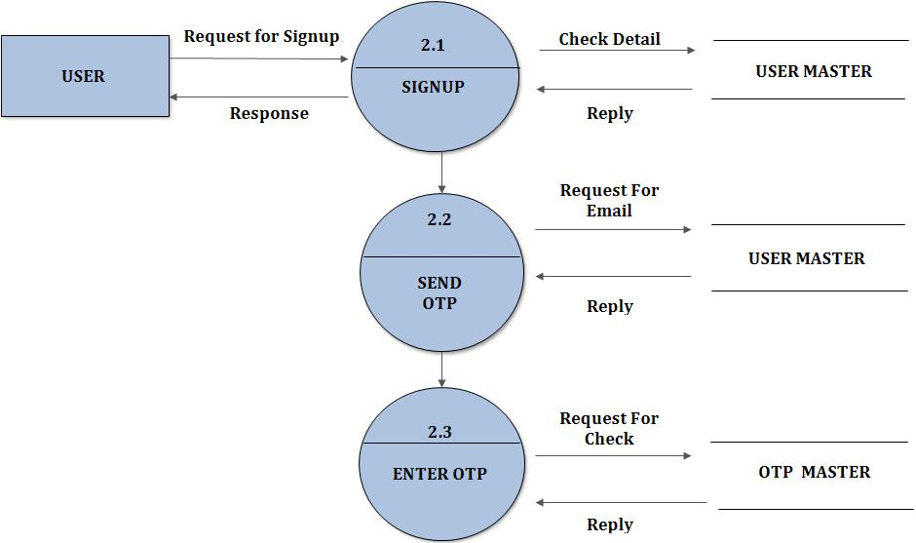

**Figure 4.16 Second Level User Side Data Flow Diagram (2.0)**

**10. Second Level User Side Data Flow Diagram (3.0)**

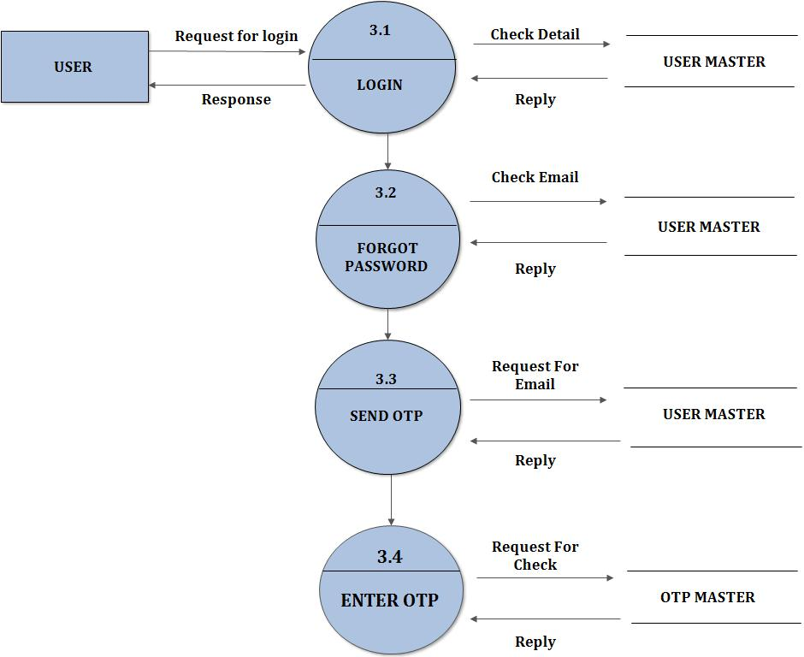

**Figure 4.17 Second Level User Side Data Flow Diagram (3.0)**

**11. Second Level User Side Data Flow Diagram (4.0)**

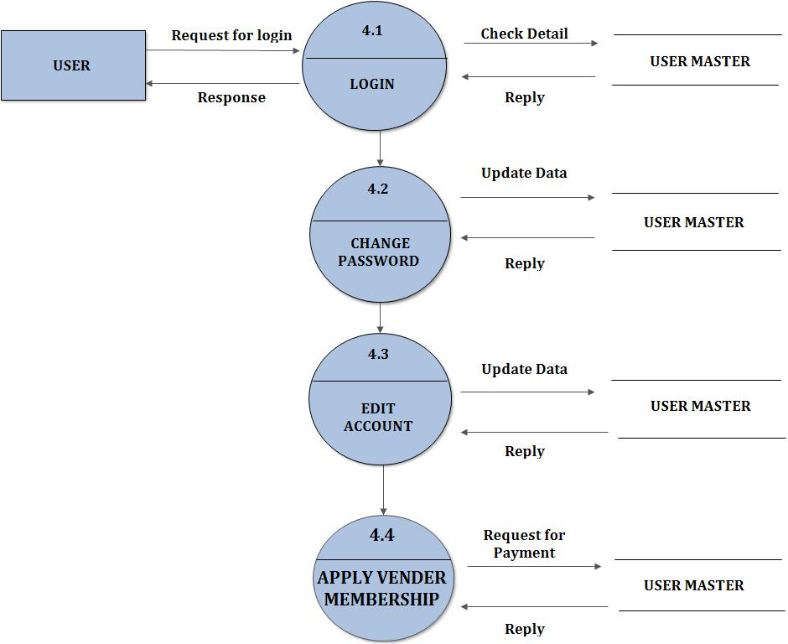

**Figure 4.18 Second Level User Side Data Flow Diagram (4.0)**

**12. Second Level User Side Data Flow Diagram (5.0)**

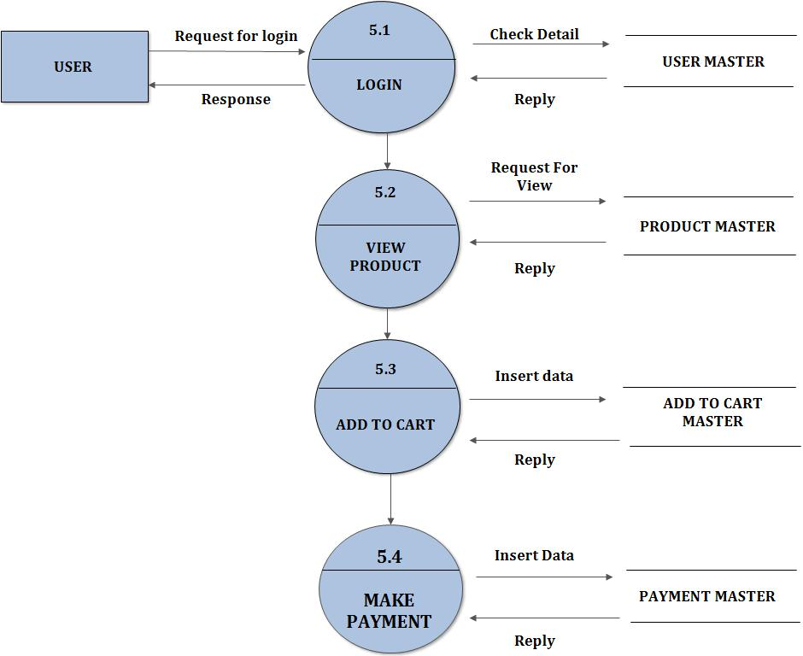

**Figure 4.19 Second Level User Side Data Flow Diagram (5.0)**

**13. Second Level User Side Data Flow Diagram (6.0)**

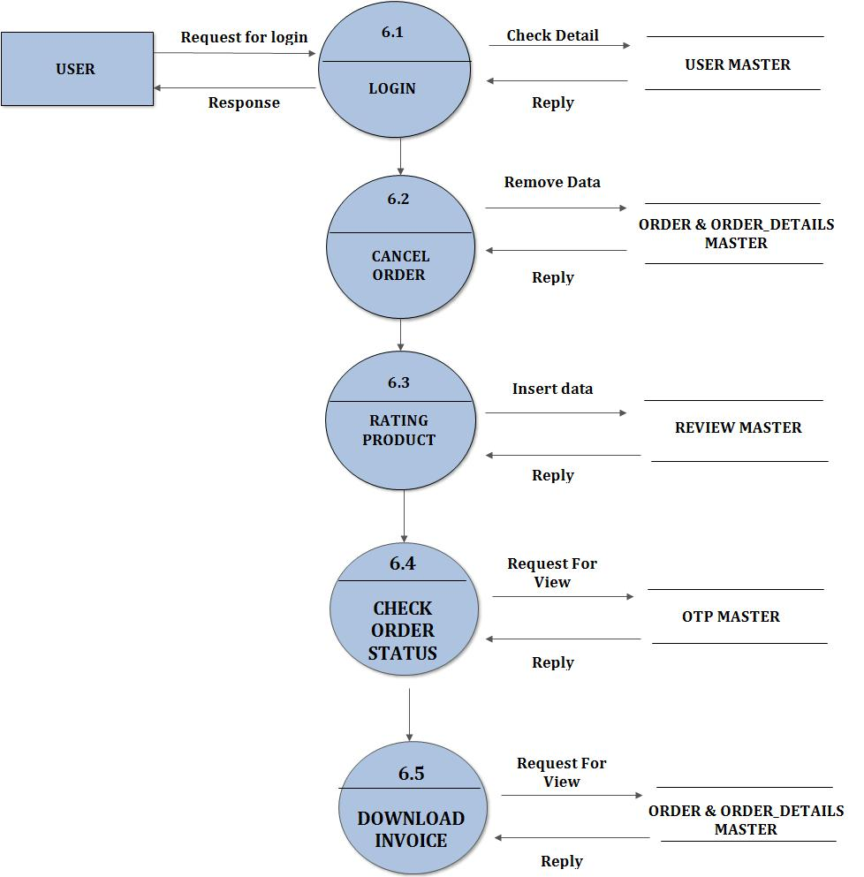

**Figure 4.20 Second Level User Side Data Flow Diagram (6.0)**

**4.4.6 Process / Control Specification**

Process Specification is use to describe the **bubble** (process) which defined in DFD. It’s a one kind of mini specification of all functions and process. We do specification for the **lowest** level (**Refined** level/**Last** level) bubble in DFD.

It describes all the inputs and outputs to the process and also describes the functionality of the process.

This process is used to perform search operation. It takes input from the user. User sends their data and then search event is performed. After performing search this process produce the output and the result to the customer.

**1. Registration Process:**



User info Registration Process Request

Registration Process is used to make Unregistered User into the Registered User.

It takes input like: Username, Password, E-mail, and Mobile No. And so on.

It stored all those User information in Database.

**2. Login Process:**



Email Id &

Password Login Provide

Login Process is used to perform the Login Operation and provide the Authority to the user.

It takes the E-mail ID and Password as an input from the User and gives the Authority as output to that User.

**4.4.7 Data Dictionary**

The data dictionary of any system is an integral component of structure, analysis since data flow diagram by themselves do not fully describe the implementation of the system. A data dictionary is catalogue a repository of the element the system.

It is developed during data flow analysis and consists the analysis involved in determining the system requirements.

**Importance of Data Dictionary:-**

* To manage the details in large system.
* To communicate a common meaning for all elements.
* To document the features of the system.

**1. Data Dictionary for User Master Table:-**

|  |  |
| --- | --- |
| **Name** | User information |
| **Alias** | None |
| **Where and how to use** | User details is used to get the information of the users/admin/ it is used to login the user |
| **Description** | Contains the information about users, name, password, email, mobile number, gender, address, city, state Etc. |

**2. Data Dictionary for Categories Master Table:-**

|  |  |
| --- | --- |
| **Name** | Product Categories Details |
| **Alias** | None |
| **Where and How to use** | Product Categories is used to get the information Type of Product, that information is used to show details Type of Product. |
| **Description** | Contains the information about Categories Name, Categories Id, and Categories Image. |

**3. Data Dictionary for Sub-Categories Master Table:-**

|  |  |
| --- | --- |
| **Name** | Product sub categories details |
| **Alias** | None |
| **Where and how to use** | Sub categories is used to get the information about brand of product , that information is used to show details product. |
| **Description** | Contains the information about subcategories id, subcategories name, categories id, subcategories image. |

**4. Data Dictionary for** **Product Master Table:**-

|  |  |
| --- | --- |
| **Name** | Product master table |
| **Alias** | None |
| **Where and how to use** | Product table is used to get the information of the product, that information is used to show details of product. |
| **Description** | Product name, product sub-category name, product amount, specification, product image. |

**5. Data Dictionary for Product Details Master Table:-**

|  |  |
| --- | --- |
| **Name** | Product details master table |
| **Alias** | None |
| **Where and how to use** | Product details master table is used to get the information of the product, that information is used to show details of product. |
| **Description** | Contains the information about – product id , product details , etc. |

**6. Data Dictionary for Add To Cart Master Table:-**

|  |  |
| --- | --- |
| **Name** | Add to Cart Details |
| **Alias** | None |
| **Where and how to use** | Add to Cart is used Add Product to Cart And Buy Products. |
| **Description** | Contains the information about Cart id, user id, product id, Quantity. |

**7. Data Dictionary for Add to Wish list Master Table:-**

|  |  |
| --- | --- |
| **Name** | Add to wish list Details |
| **Alias** | None |
| **Where and how to use** | Add to wish list is used Add Product to wish list And Buy Products. |
| **Description** | Contains the information about wish list id, user id, product id, Quantity. |

**8. Data Dictionary for Order Master Table:-**

|  |  |
| --- | --- |
| **Name** | Order master |
| **Alias** | None |
| **Where and how to use** | Order table is used to get the information of the user to order |
| **Description** | Contains the information about- Order id, user id. |

**9. Data Dictionary for Order Details Master Table:-**

|  |  |
| --- | --- |
| **Name** | Order details master |
| **Alias** | None |
| **Where and how to use** | Order details table is used to get the information of the user order product. |
| **Description** | Contains the information about –id, Order id, Dealer id, date & time, Quantity, product id, price, total price, payment type. |

**10. Data Dictionary for Payment Master Table:-**

|  |  |
| --- | --- |
| **Name** | Payment master table |
| **Alias** | None |
| **Where and how to use** | Payment master table is used to get the information of the user transaction details. |
| **Description** | Contains the information about- pay id, User id, pay order id, pay status, pay transaction id, pay amount, date & time, pay bank name. |

**11. Data Dictionary for Review Master Table:-**

|  |  |
| --- | --- |
| **Name** | Review master |
| **Alias** | None |
| **Where and how to use** | Rating master table is used to get the information of the user review product. |
| **Description** | Contains the information about- review id, User id, product id, comment, date, and rating. |

**12. Data Dictionary for OTP Master Table:-**

|  |  |
| --- | --- |
| **Name** | OTP master |
| **Alias** | None |
| **Where and how to use** | OTP master table is used to get the information of the user Registration. |
| **Description** | Contains the information about- id, code, status, and date. |

**4.4.8 E-R Diagram**

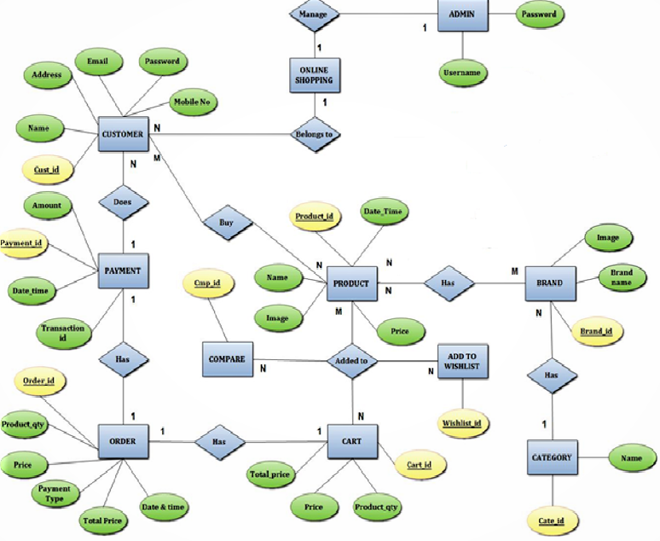

**4.4.9 Data Object Description**

The following contains information on how to retrieve database information for MySQL objects such as databases, views, and users. The method of retrieving system information from MySQL is dependent on the MySQL version.

**1. Databases:**

This is a query to retrieve MySQL databases for MySQL 5 or newer:

**Select scheme name from information schema.schemate**

This is a query to retrieve MySQL databases for all version of MySQL:

**Show databases**

**2. Views:**

This is a query to retrieve MySQL Views or for MySQL 5 or newer:

**Select** **TABLE_NAME from** **information_schema.views** **where** **Table schema = 'MySQL'**

**3. Users:**

This is a query to retrieve MySQL users:

**Select distinct user from MySQL. User where user < > '' order by user**

**Chapter – 5.Software Design**

5.1 Project Design Process Hierarchy

5.2 Database Design

5.2.1 Justification of Normalization

5.3 Architectural Design

5.4 Algorithm Development / Pseudo-code

5.5 User Interface Design

5.6 Security Issues

5.7 Quality / Reliability Measures

5.8 System Map

**5.1 Project Design Process Hierarchy**

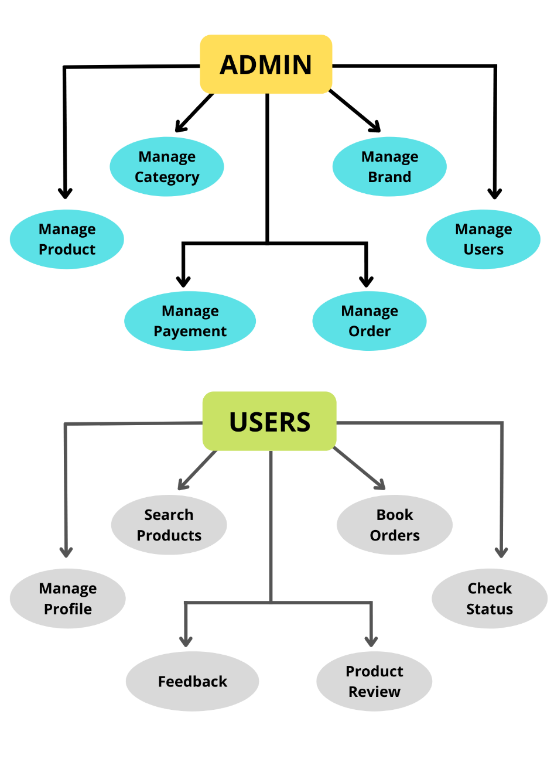

**5.2 Database Design**

**Admin Table:**

|  |  |  |  |
| --- | --- | --- | --- |
| Field Name | Data Type | Size | Description |
| id | int | 11 | Primary Key |
| name | Varchar latin1_swedish_ci | 100 | Admin Name |
| gender | Varchar latin1_swedish_ci | 100 | Admin Gender |
| phone | bigint | 10 | Admin Mobile Number |
| email | Varchar latin1_swedish_ci | 11 | Admin Email |
| password | Varchar latin1_swedish_ci | 100 | Password |
| con_pass | Varchar latin1_swedish_ci | 100 | Confirm Password |

**Product Category:**

|  |  |  |  |
| --- | --- | --- | --- |
| Field Name | Data Type | Size | Description |
| id | int | 11 | Primary Key |
| name | Varchar latin1_swedish_ci | 100 | Category Name |
| Total_product | int | 11 | Total Product in this Category |

**Product Sub-Category:**

|  |  |  |  |
| --- | --- | --- | --- |
| Field Name | Data Type | Size | Description |
| id | int | 11 | Primary Key |
| name | Varchar latin1_swedish_ci | 100 | Sub-Category Name |
| Cat_id | int | 100 | Category id |

**Product Brand:**

|  |  |  |  |
| --- | --- | --- | --- |
| Field Name | Data Type | Size | Description |
| id | int | 11 | Primary Key |
| name | Varchar latin1_swedish_ci | 100 | Brand Name |
| logo | Varchar latin1_swedish_ci | 100 | Brand Logo (image) |
| Total_product | int | 11 | Total Product in this Brand |

**Product:**

|  |  |  |  |
| --- | --- | --- | --- |
| Field Name | Data Type | Size | Description |
| id | int | 11 | Primary Key |
| name | Varchar latin1_swedish_ci | 100 | product Name |
| description | Varchar latin1_swedish_ci | 100 | Product description |
| price | int | 11 | Product price |
| brand | Varchar latin1_swedish_ci | 11 | Product Brand name |
| cat | Varchar latin1_swedish_ci | 100 | Product category name |
| Sub_cat | Varchar latin1_swedish_ci | 100 | Product sub-category name |
| image | Varchar latin1_swedish_ci | 100 | product image |
| status | int | 11 | Product status |

**Product Cart:**

|  |  |  |  |
| --- | --- | --- | --- |
| Field Name | Data Type | Size | Description |
| id | int | 11 | Primary Key |
| user_id | int | 11 | User Login Id |
| product_id | int | 11 | Product Id (cart product) |
| product_qty | int | 11 | Total Product in this Cart |
| total_price | int | 11 | Total Price of Cart Product |

**Users Table:**

|  |  |  |  |
| --- | --- | --- | --- |
| Field Name | Data Type | Size | Description |
| id | int | 11 | Primary Key |
| name | Varchar latin1_swedish_ci | 100 | Admin Name |
| gender | Varchar latin1_swedish_ci | 100 | Admin Gender |
| phone | bigint | 10 | Admin Mobile Number |
| email | Varchar latin1_swedish_ci | 11 | Admin Email |
| password | Varchar latin1_swedish_ci | 100 | Password |
| con_pass | Varchar latin1_swedish_ci | 100 | Confirm Password |
| image | Varchar latin1_swedish_ci | 100 | User image (profile picture) |
| city | int | 11 | User city |
| address | Varchar latin1_swedish_ci | 200 | User address |
| lane | Varchar latin1_swedish_ci | 100 | User lane |
| landmark | Varchar latin1_swedish_ci | 100 | User landmark |
| pincode | tinyint | 6 | User address pincode |
| verify | tinyint | 6 | Email verification code (OTP) |
| status | int | 11 | User status |

**Product Wish List:**

|  |  |  |  |
| --- | --- | --- | --- |
| Field Name | Data Type | Size | Description |
| id | int | 11 | Primary Key |
| user_id | int | 11 | User Login Id |
| product_id | int | 11 | Product Id (cart product) |

**Product Review:**

|  |  |  |  |
| --- | --- | --- | --- |
| Field Name | Data Type | Size | Description |
| id | int | 11 | Primary Key |
| user_id | int | 100 | User Login id |
| product_id | int | 11 | Product Id (product review) |
| rating | int | 11 | User given product rating |
| message | Varchar latin1_swedish_ci | 200 | User give a review for specific product |

**Users City:**

|  |  |  |  |
| --- | --- | --- | --- |
| Field Name | Data Type | Size | Description |
| id | int | 11 | Primary Key |
| name | Varchar latin1_swedish_ci | 100 | City Name |
| total_user | int | 11 | Total user in this city |

**Users Feedback:**

|  |  |  |  |
| --- | --- | --- | --- |
| Field Name | Data Type | Size | Description |
| id | int | 11 | Primary Key |
| user_id | int | 11 | User Login Id |
| comment | Varchar latin1_swedish_ci | 300 | Users send feedback |

**Order:**

|  |  |  |  |
| --- | --- | --- | --- |
| Field Name | Data Type | Size | Description |
| id | int | 11 | Primary Key |
| user_id | int | 11 | User Login Id |
| date | date |  | User order date |
| product_name | Varchar latin1_swedish_ci | 300 | All product name |
| quantity | int | 11 | Product quantity |
| price | int | 11 | Product price |
| Total_price | int | 11 | Total product price |
| Pay_type | int | 11 | User choose payment option |

**Order Cancel:**

|  |  |  |  |
| --- | --- | --- | --- |
| Field Name | Data Type | Size | Description |
| id | int | 11 | Primary Key |
| user_id | int | 11 | User Login Id |
| Order_id | int | 11 | Order id |
| reason | Varchar latin1_swedish_ci | 300 | Product cancel reason |

**Order Return:**

|  |  |  |  |
| --- | --- | --- | --- |
| Field Name | Data Type | Size | Description |
| id | int | 11 | Primary Key |
| user_id | int | 11 | User Login Id |
| Order_id | int | 11 | Order id |
| reason | Varchar latin1_swedish_ci | 300 | Product Return reason |

**Invoice:**

|  |  |  |  |
| --- | --- | --- | --- |
| Field Name | Data Type | Size | Description |
| id | int | 11 | Primary Key |
| user_id | int | 11 | User Login Id |
| product_name | Varchar latin1_swedish_ci | 300 | All product name |
| quantity | int | 11 | Product quantity |
| price | int | 11 | Product price |
| Total_price | int | 11 | Total product price |
| Pay_type | int | 11 | User choose payment option |
| Order_date | date |  | User order date |
| status | int | 11 | Order status |

**Payment Type:**

|  |  |  |  |
| --- | --- | --- | --- |
| Field Name | Data Type | Size | Description |
| id | int | 11 | Primary Key |
| name | Varchar latin1_swedish_ci | 100 | Payment type name |

**5.2.1 Justification of Normalization**

**Normalization**

Database Normalization is a technique of organizing the data in the database. Normalization is a systematic approach of decomposing tables to eliminate data redundancy and undesirable characteristics like Insertion, Update and Deletion Anomalies. It is a multi-step process that puts data into tabular form by removing duplicated data from the relation tables.

***Normalization is used for mainly two purposes,***

* Eliminating redundant (useless) data.
* Ensuring data dependencies make sense i.e. data is logically stored.

**Normalization Rule**

***Normalization rule are divided into following Normal Form:-***

1. First Normal Form
2. Second Normal Form
3. Third Normal Form
4. **First Normal Form (1NF)**

As per First Normal Form, no two Rows of data must contain repeating group of information i.e. each set of column must have a unique value, such that multiple columns cannot be used to fetch the same row. Each table should be organized into rows, and each row should have a primary key that distinguishes it as unique.

The Primary key is usually a single column, but sometimes more than one column can be combined to create a single primary key. For example consider a table which is not in First Normal Form.

In First Normal Form, any row must not have a column in which more than one value is saved, like separated with commas. Rather than that, we must separate such data into multiple rows.

Using the First Normal Form, data redundancy increases, as there will be many columns with same data in multiple rows but each row as a whole will be unique.

**2. Second Normal Form (2NF)**

As per the Second Normal Form there must not be any partial dependency of any column on primary key. It means that for a table that has concatenated primary key, each column in the table that is not part of the primary key must depend upon the entire concatenated key for its existence. If any column depends only on one part of the concatenated key, then the table fails Second Normal Form.

In example of First Normal Form there are two rows for Adam, to include multiple subjects that he has opted for. While this is searchable, and follows First Normal Form, it is an inefficient use of space. Also in the above Table in First Normal Form, while the candidate key is {Student, Subject}, Age of Student only depends on Student column, which is incorrect as per Second Normal Form. To achieve second normal form, it would be helpful to split out the subjects into an independent table, and match them up using the student names as foreign keys.

**3. Third Normal Form (3NF)**

Third Normal form applies that every non-prime attribute of table must be dependent on primary key, or we can say that, there should not be the case that a non-prime attribute is determined by another non-prime attribute. So this Transitive Functional Dependency should be removed from the table and also the table must be in Second Normal form. For example, consider a table with following fields.

***The advantage of removing transitive dependency is,***

1. Amount of data duplication is reduced.
2. Data integrity achieved.

**5.3 Architectural Design:-**

When you making a design of system, it is more necessary to develop the architectural design of system which is useful for basic flow and the detailed.

The Architectural Design defines the relationships between The Design Pattern and the constraint of the system. It derived from system specification, the analysis model like Flow chart and interaction of subsystem defined in the model.

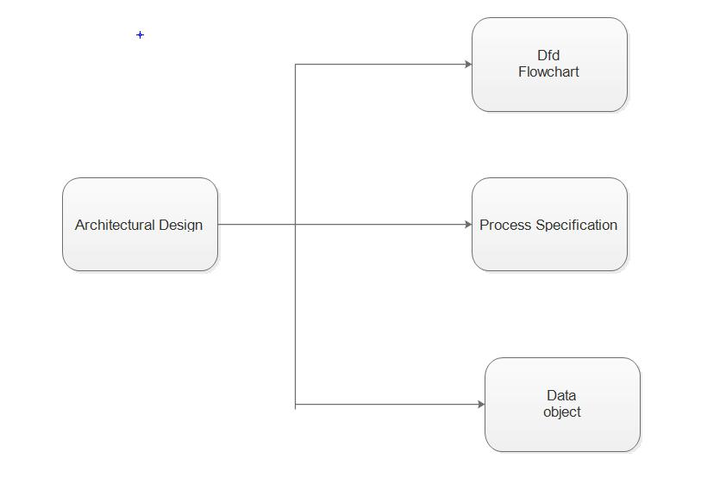

**Figure 5.3 Architectural Design**

**Architectural with Data Design:-**

In this Design we describe all the aspects to relate to external data and entities for the software to be built. Here we consider the data connected recourses with our system and connection with the database.

***In Architectural Data Design, we follow the two abstraction:***

* **High Level Abstraction (Data Abstraction):-**

Data Abstraction is the collection of data that describes the data objects.

* **Architecture with Data Flow:-**

In this Architectural Design consider the Data flows of the system. For Knowing the flow of system we consider some faces of the analysis like Data Flow Diagram and Process specification which gives the detail transaction and transform flow.

* **Mapping with Architectural Design:**

Software requirements can be mapped into various representation of data model. The Architectural Design Consider the various mapping flow for developing a good and attractive design of the system.

1. **Transform Flow:-**

In Transform Flow we consider the fundamental system or basic system model as level-0 of Data Flow Diagram. In our system we get and pass the information related to system at the basic level so, here we show the basic level transform flow.

1. **Transaction Flow:-**

Here we consider the detailed information of data flow during the requirement analysis more detailed flow models would be created for the system such as control and process specification, flow diagram and data dictionary.

**5.4 Pseudo code:-**

**1. Pseudo Code for login:-**

Set the login page

Input the username and password

If username and password is correct

Login the user

Else

Login fail and go to the login page

**2 .Pseudo code for form validation:-**

Input the field give you in the page

If input field value is correct

Input value is accept.

Else

Return to input form

**3. Pseudo code for registration:-**

Set the register page

Input the required field

If input is correct

User is register successfully

Else

Going to again register page

**5.5 User Interface Design:-**

* **Home Page:-**

The initial page that is loaded when visitors come to our website.

* **User Dashboard:-**

This page will only be viewable to the owner of the profile. It will list historical information about user’s activity.

* **Resource Pages:-**

About, Services, etc.

**5.6 Security Issues:-**

* Visitor or user cannot access unauthorized pages.
* One member cannot access another member data.
* Login and logout managed.
* User time duration of logged in session is maintained.
* Managed all pages linked with each other.

Perform all member security level and perform an authentication and give person account to each member for security purpose.

Managed the bunch of data of a particular member so that if can have the security purpose and keep the data private.

**5.7 Quality Measures:-**

To produce high quality software is a goal to develop the software with all kinds of the satisfaction with user, cost and assurance and also with the developers.

If requirement is not consider or gathered properly then, the lack of the adaption or confirmation to requirement is also lack of quality software first we define and consider the meaningful and useful requirement.

To develop quality software we must compare our software with some known data.

***So far that we measure our software in three different divisions:***

1. Software Operation
2. Software Revision
3. Software Transition
4. **Software Operation:-**

In these we define the quality with correction, reliability, usability, efficiency and integrity.

In our system, these are many different modules and sub modules that exist and manage their quality we follow as above factors.

* 1. **Correctness:**

If any changes have occurred in our modules, then we can easily correct them. So the qualities of those modules become as usual and will not decrease.

* 1. **Integrity:**

If all the modules are completed successfully, then we can integrate them and manage the quality of all modules.

1. **Software Revision:-**

In this, we are concerned with those aspects related to modification of the program such as maintainability, testability.

1. **Software Transition:-**

It deals with the quality factors lie portability, interoperability and reusability.

* + 1. **Interoperability:**

It is the effort required to couple the system with other system and its relation between two modules.

* + 1. **Reusability:**

It is the extent to which parts of software can be reused in other related applications

**5.8 System Map:-**

**Admin Side:-**

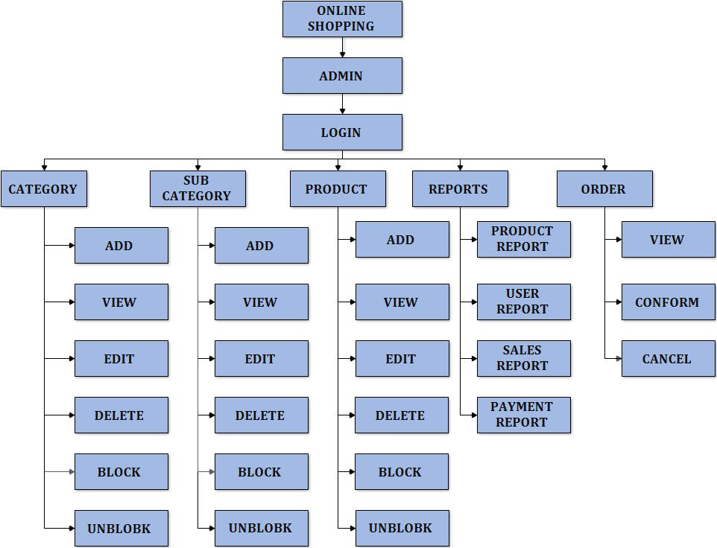

**Client Side:-**

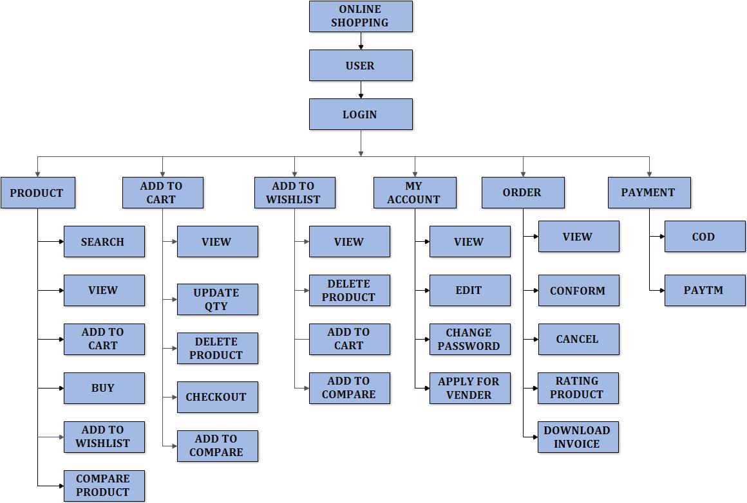

**Chapter – 6. Software Coding**

6.1 Tools & Techniques

6.2 Result Snapshot

6.3 System generated Reports

**6.1 Tools & Techniques**

In each and every System there is need of two different ends to handle the system. Each System requires the main Platform perform all tasks that will appear in system and these tasks will be performed by only Front End.

The main need of taking front end is that all programming that will be perform according to the environment and facility by the opted front end and taking back end is that all database are kept in that base.

In My system (**Inventory Management**) we choose most acceptable technologies to work with and which can provide great community support. In This system there are mainly two factors **Frontend & Backend**.

A **Larval Framework** used as frontend technology and PHP used as Backend. MS SQL Server Database to store & retrieve data.

**HARDWARE REQUIREMENT**

Given below is recommended hardware specification that required at client side to run software.

|  |  |
| --- | --- |
| **Processor** | I3 Processor |
| **Ram** | 6 GB RAM |
| **SDD** | 512 GB Hard Disk |

**SOFTWARE REQUIREMENT**

Given below is recommended specification of require software to develop the system.

|  |  |
| --- | --- |
| **Operating System** | Microsoft Windows 10 |
| **Front End** | Sublime Text 3.2.2 |
| **Server** | Apache, Wamp Server Version **– 2.4.46** |
| **Back End** | MySQL(phpmysqladmin) |
| **Tools Used** | HTML, CSS, JavaScript, Ajax , Bootstrap, PHP, JQuery |
| **Framework** | Laraval Framework Version – **8.79.0**  Composer Version – **2.2.4** |
| **Compatible Browser** | Mozilla Firefox, Google Chrome, etc. |

**6.2 Result Snapshot**

**ADMIN:**

**Admin Login:**

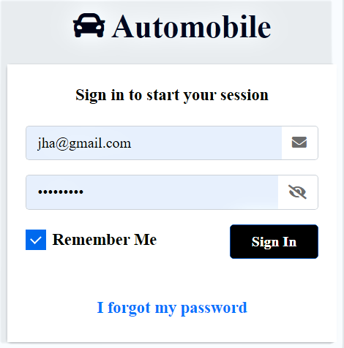

**Admin Forgot Password:**

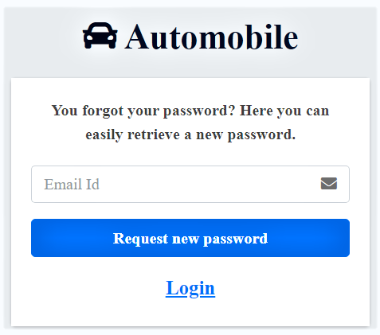

**Admin Recover Password:**

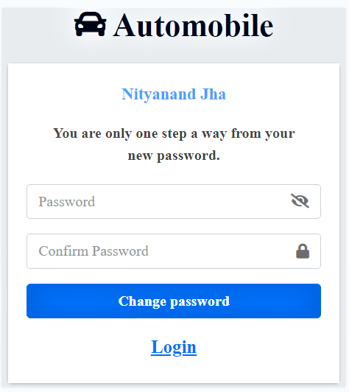

**Admin Dashboard:**

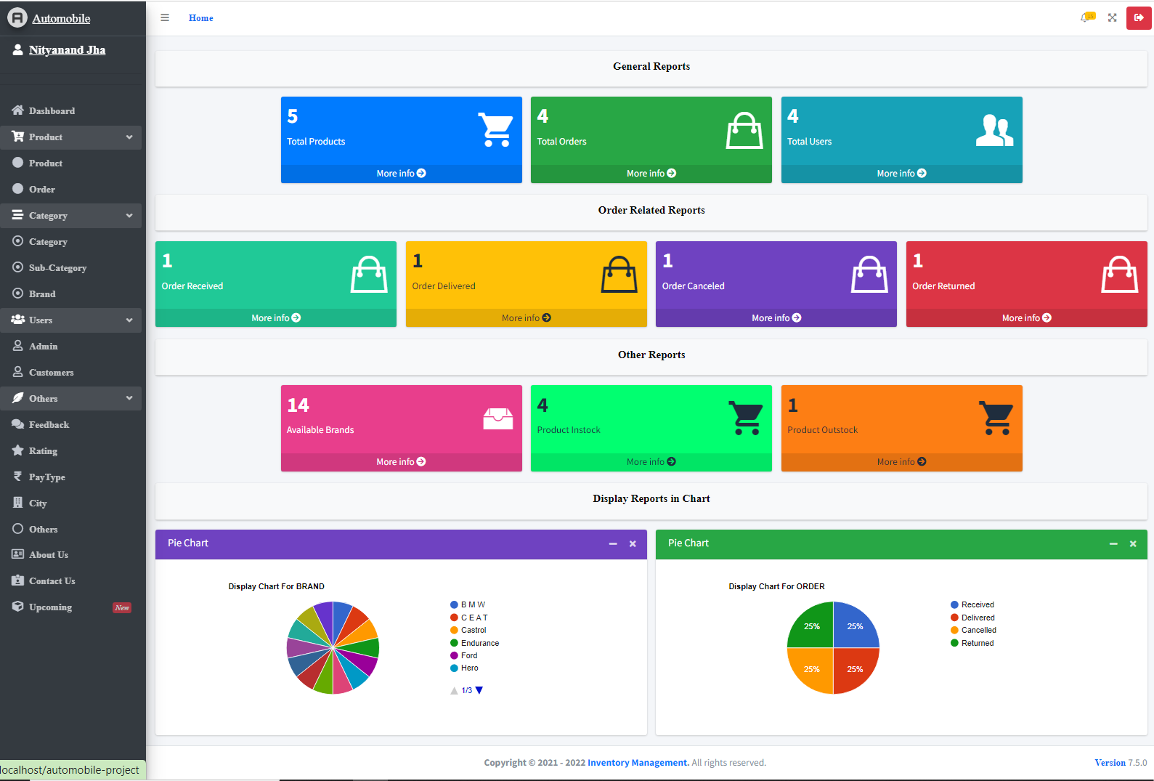

**Display All Product:**

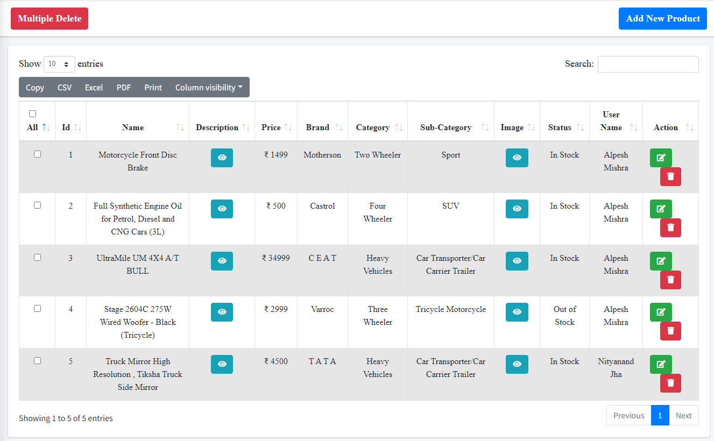

**Display Product Images:**

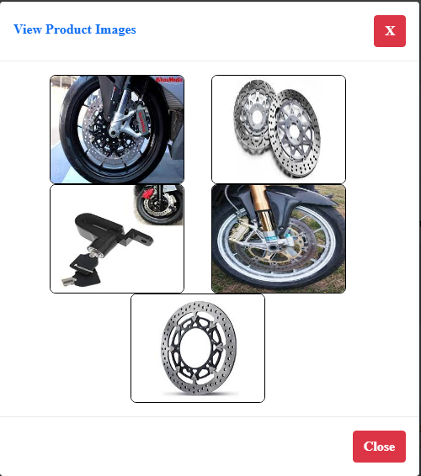

**Display Product Description:**

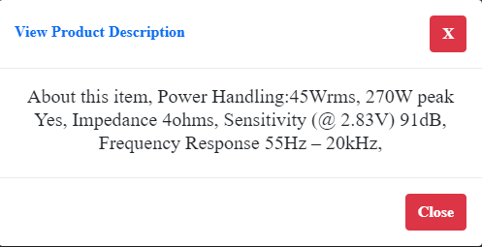

**Add New Product:**

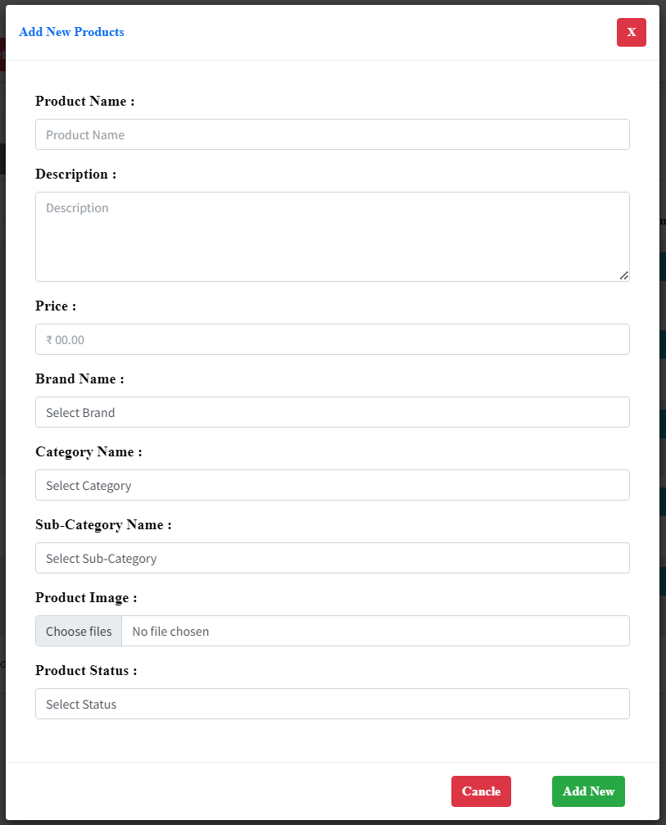

**Update Product:**

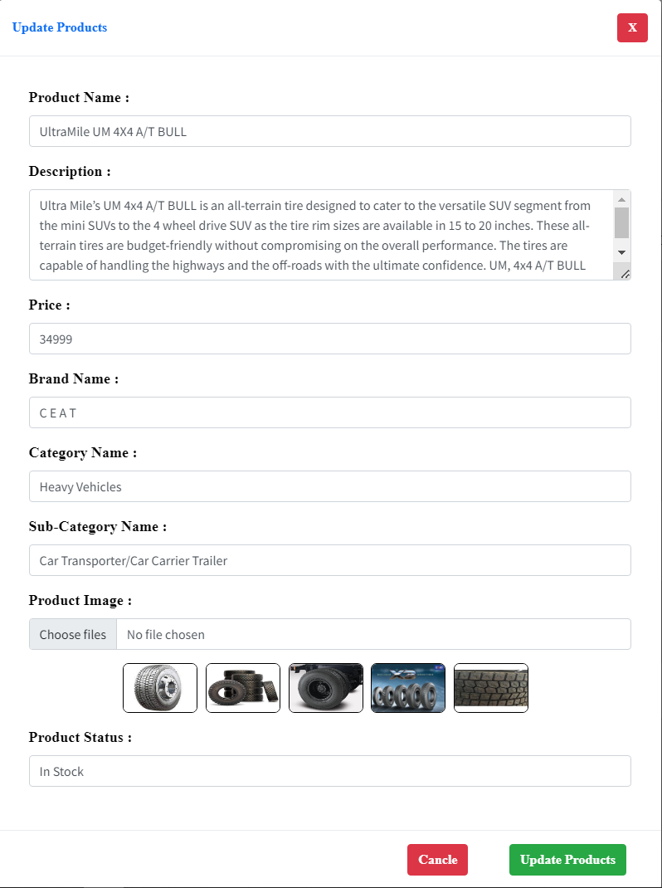

**Order Received:**

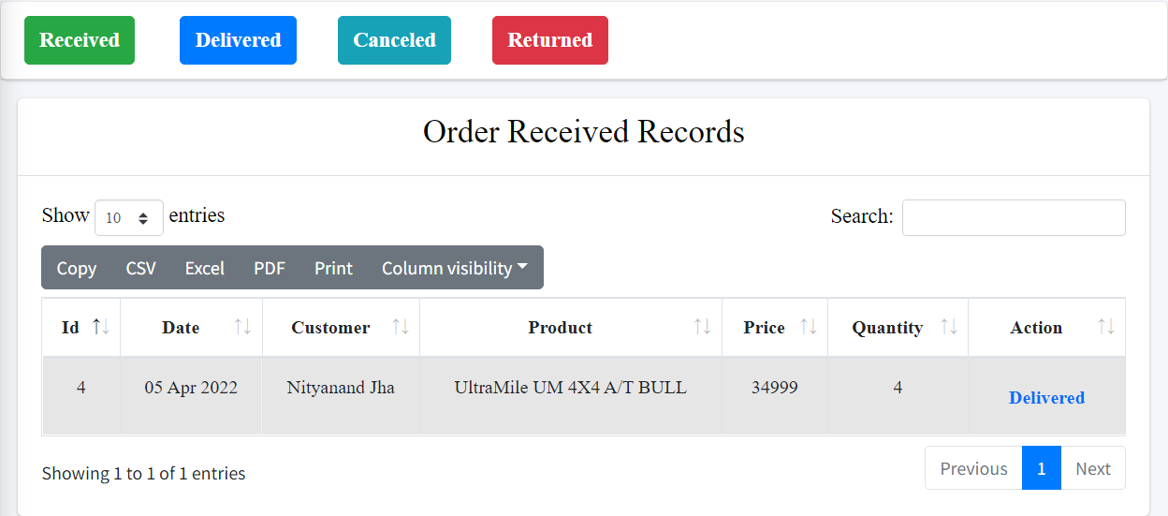

**Order Delivered:**

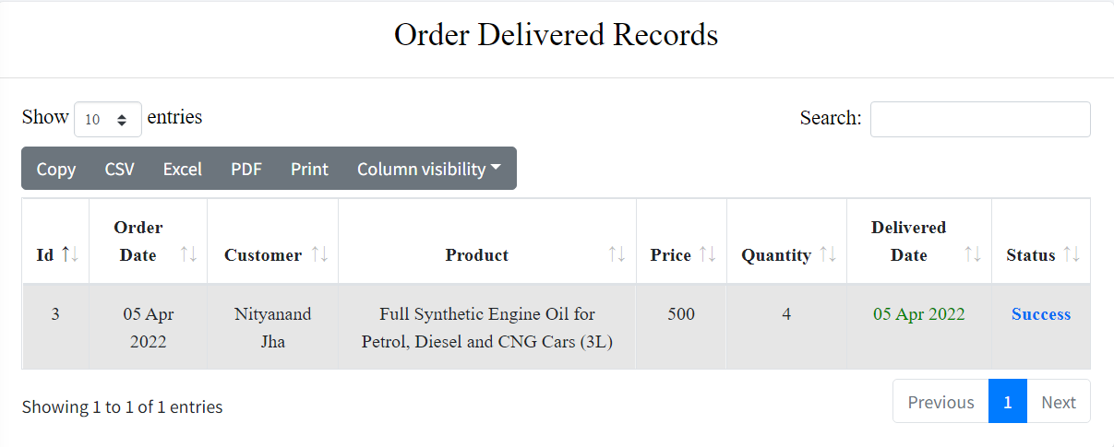

**Order Cancelled:**

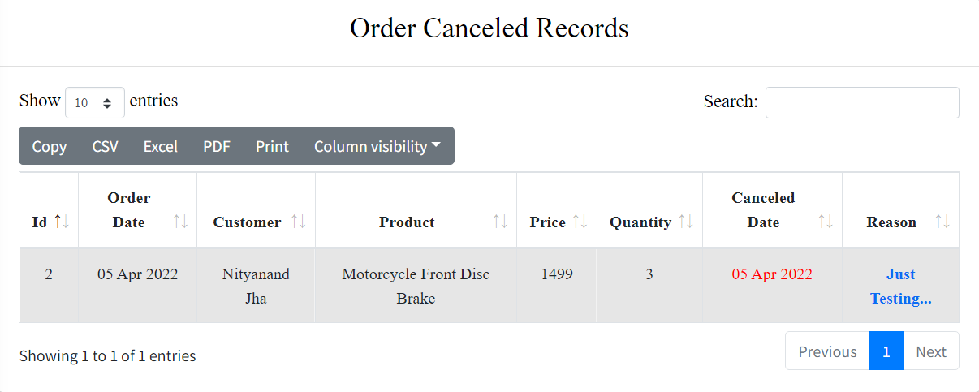

**Order Returned:**

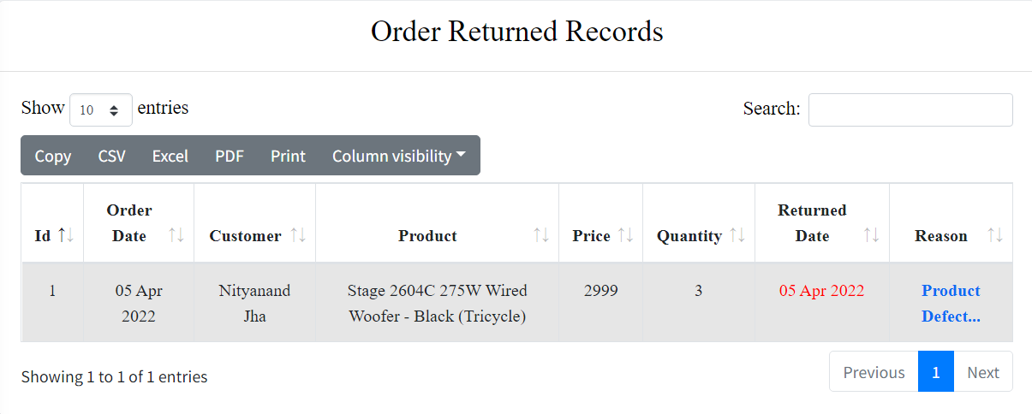

**Display All Category:**

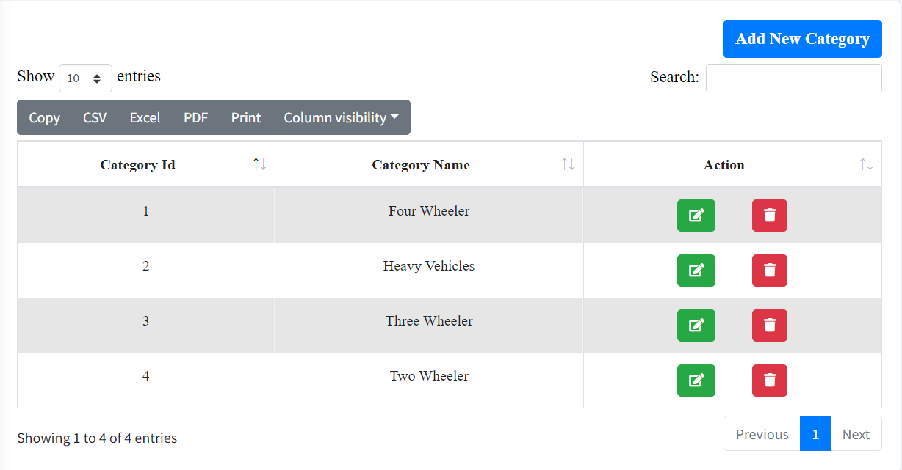

**Add New Category:**

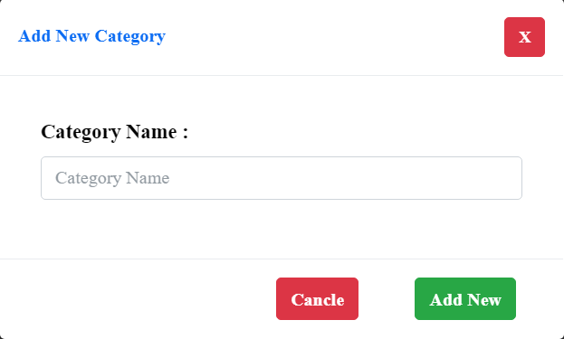

**Update Category:**

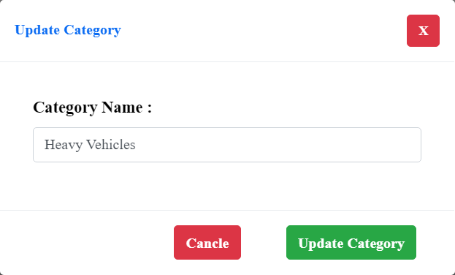

**Display All Sub-Category:**

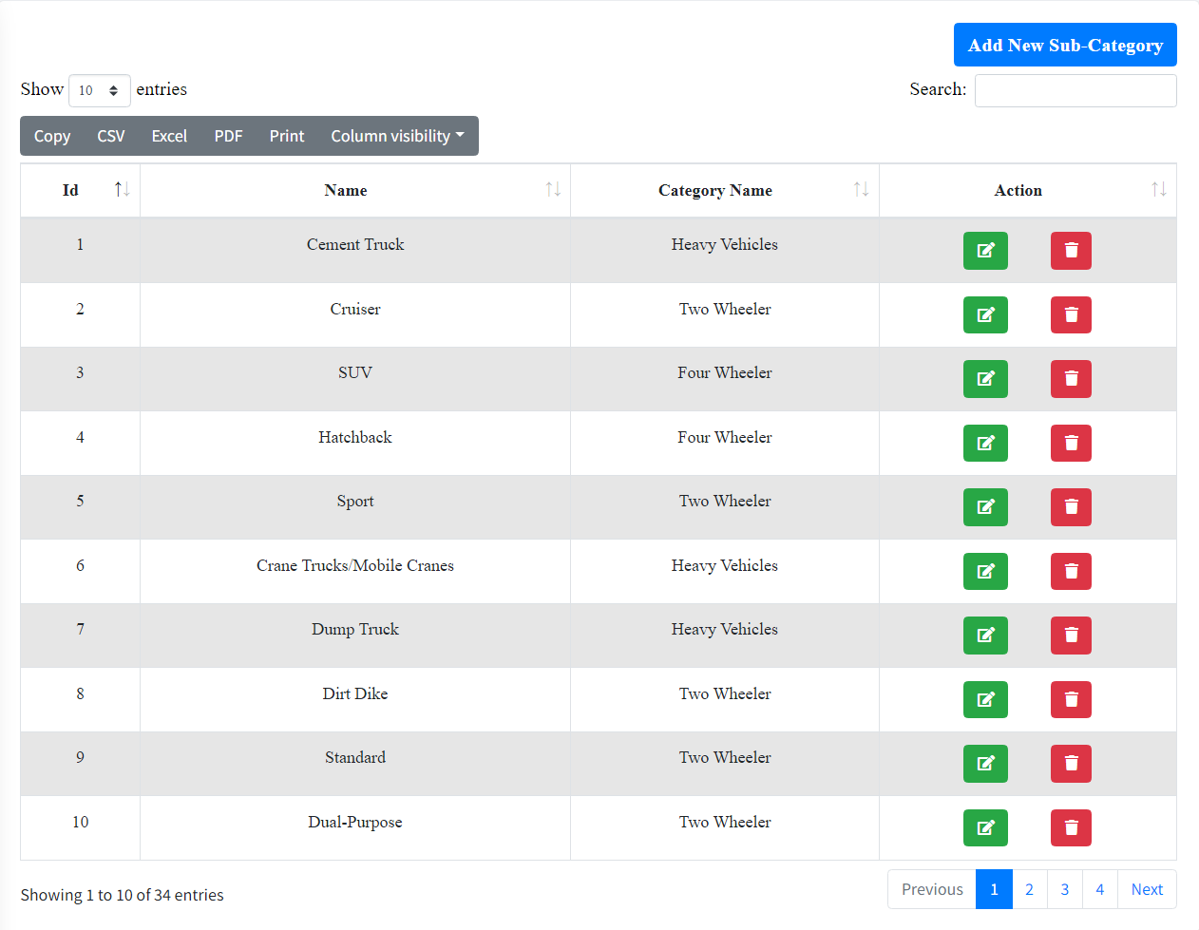

**Add New Sub-Category:**

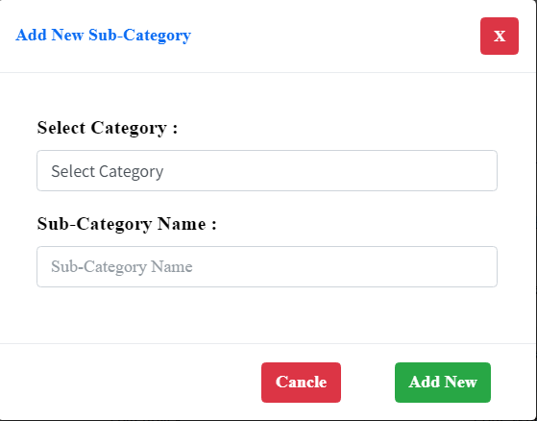

**Update Sub-Category:**

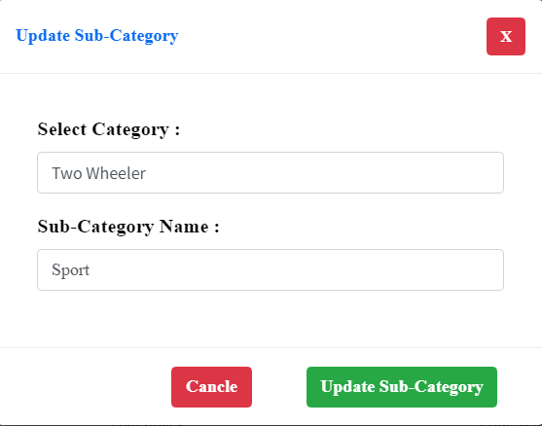

**Display All Brands:**

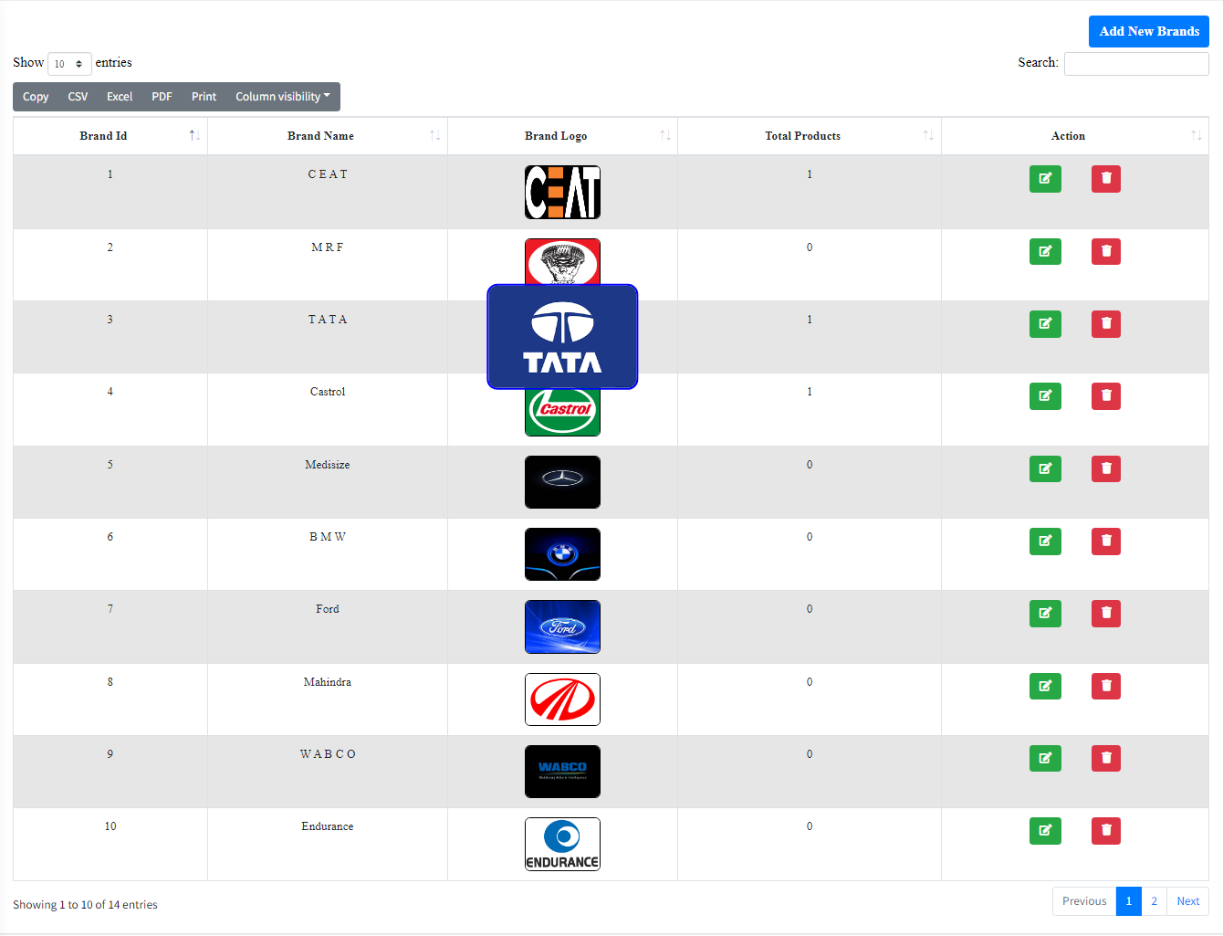

**Add New Brands:**

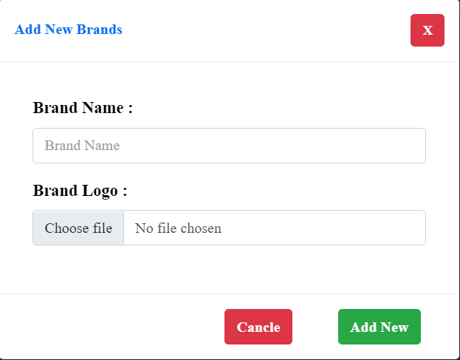

**Update Brands:**

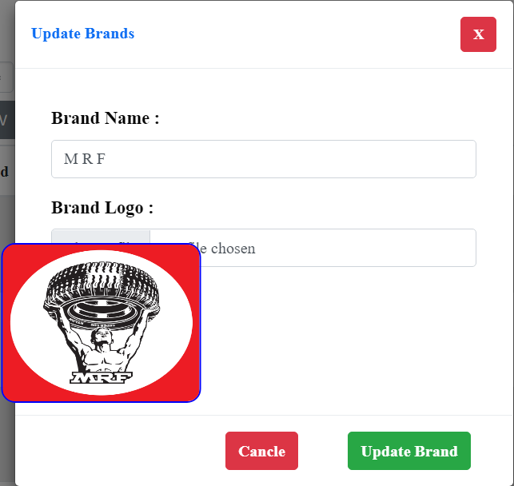

**Display All Admin:**

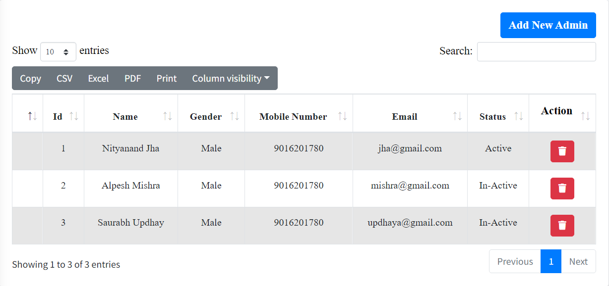

**Display All Users:**

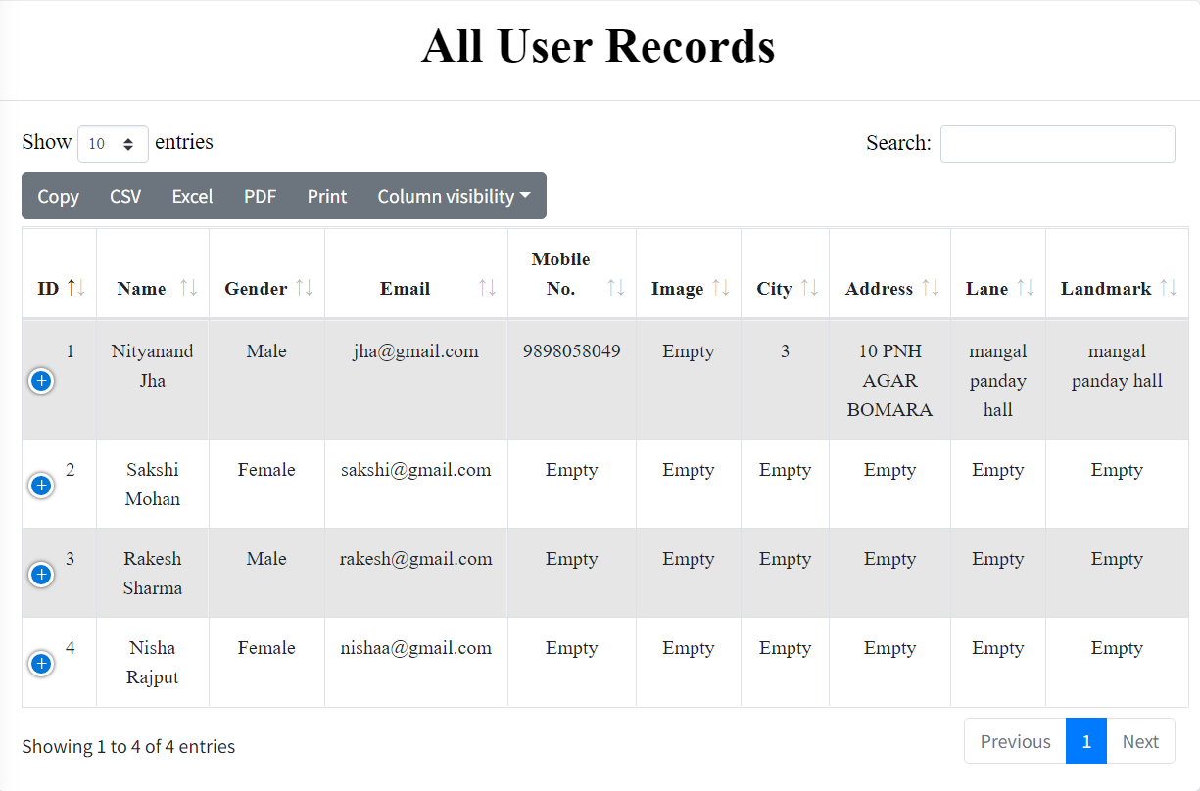

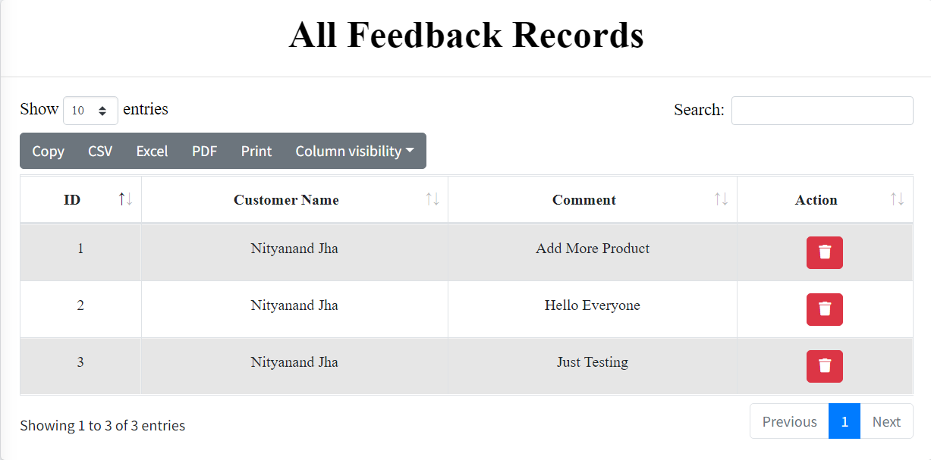

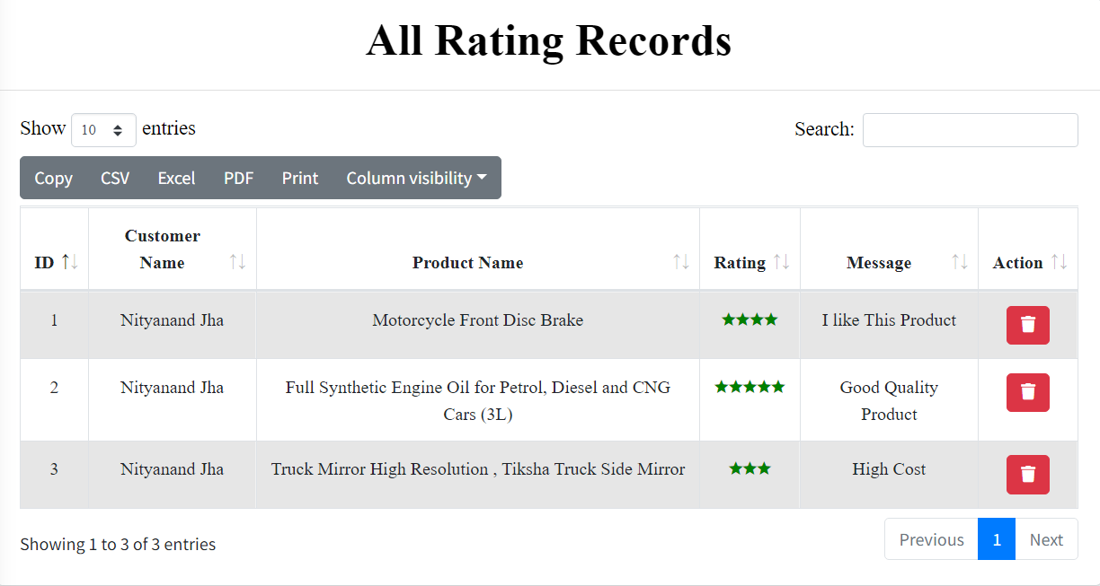

**Display All Payment Types:**

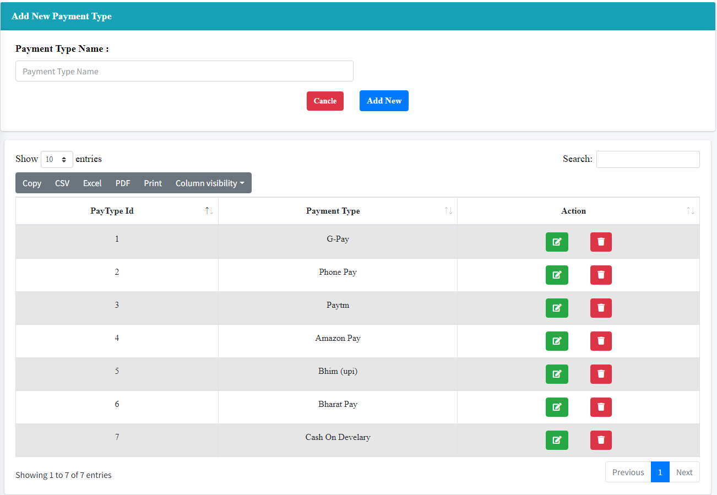

**Update Payment Type:**

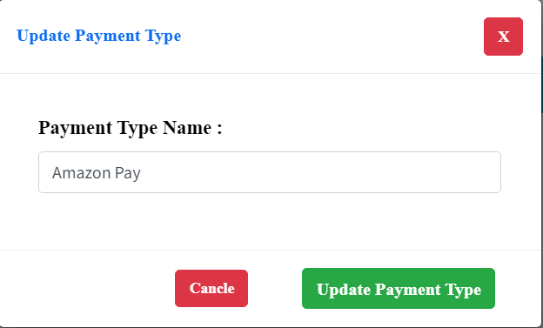

**Display All City’s:**

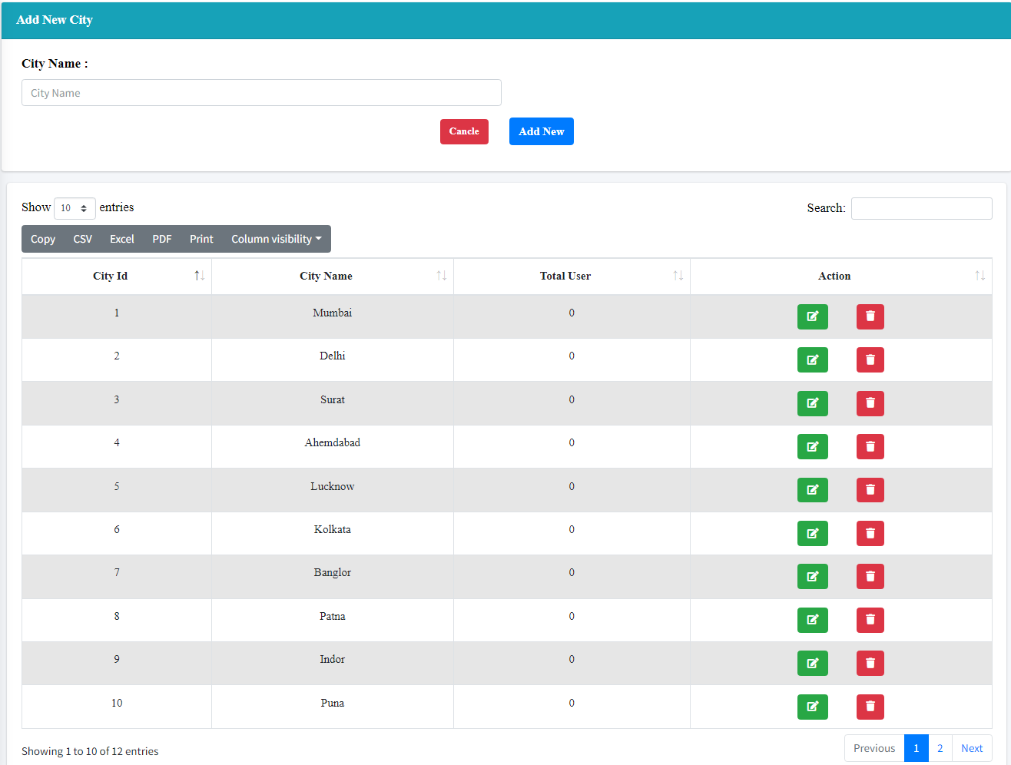

**Update City:**

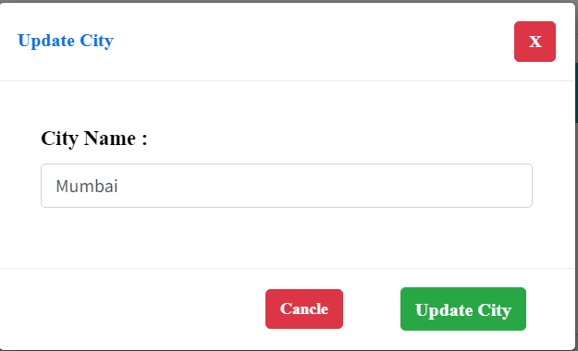

**USERS:**

**User Register Page:**

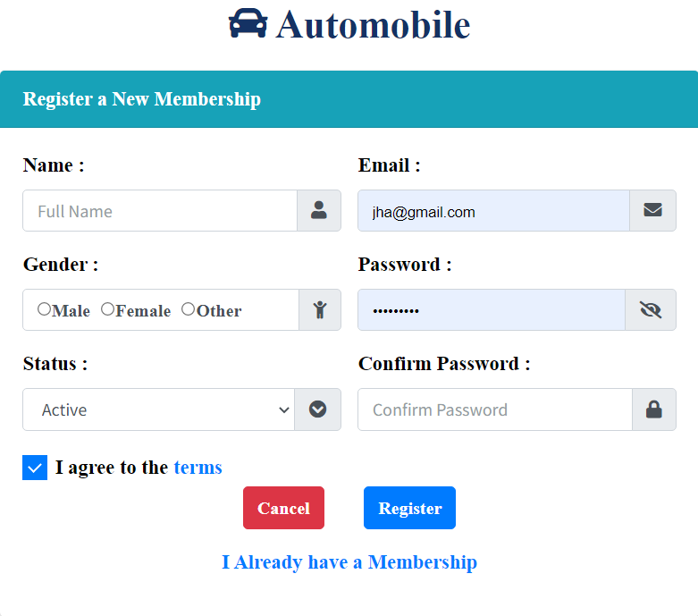

**User Login:**

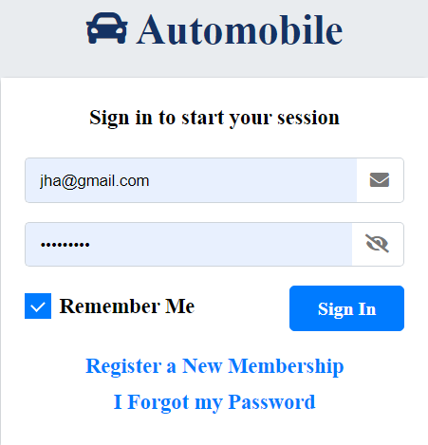

**User Forgot Password:**

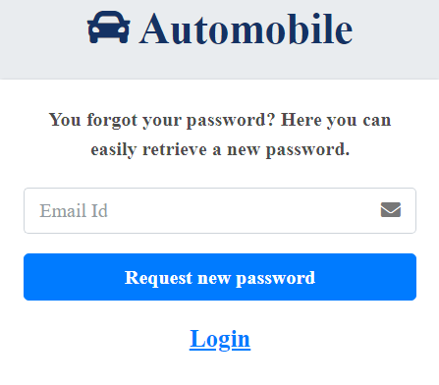

**User Recover Password:**

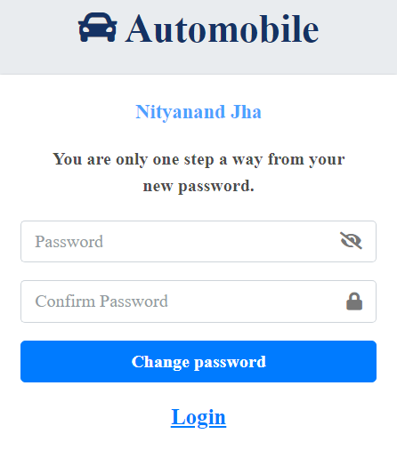

**Home Page:**

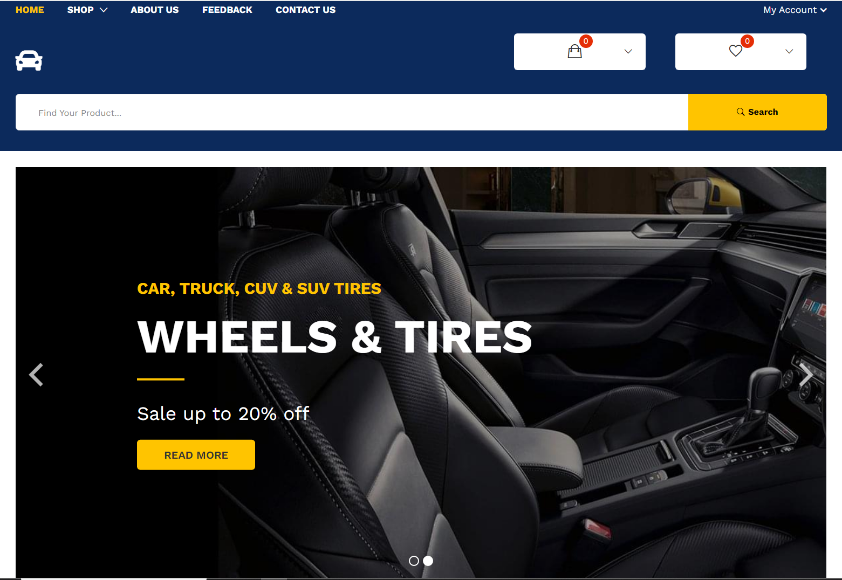

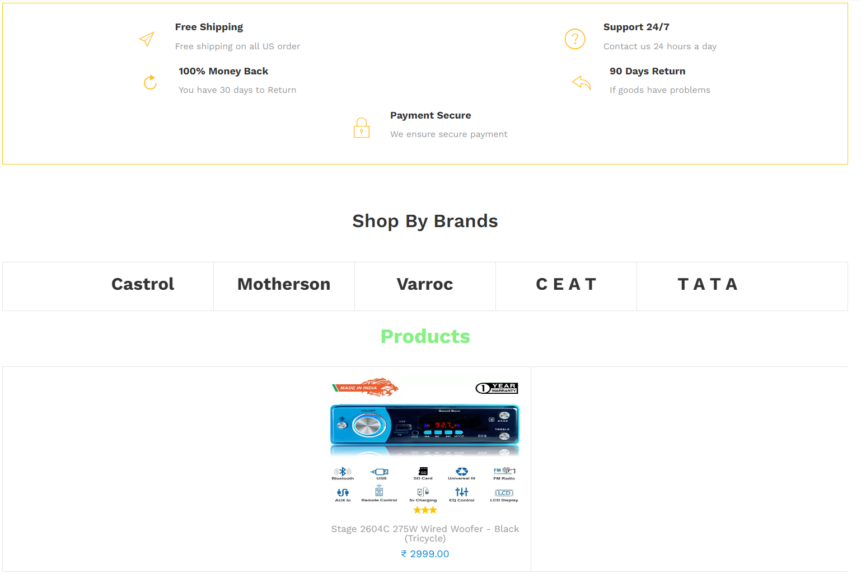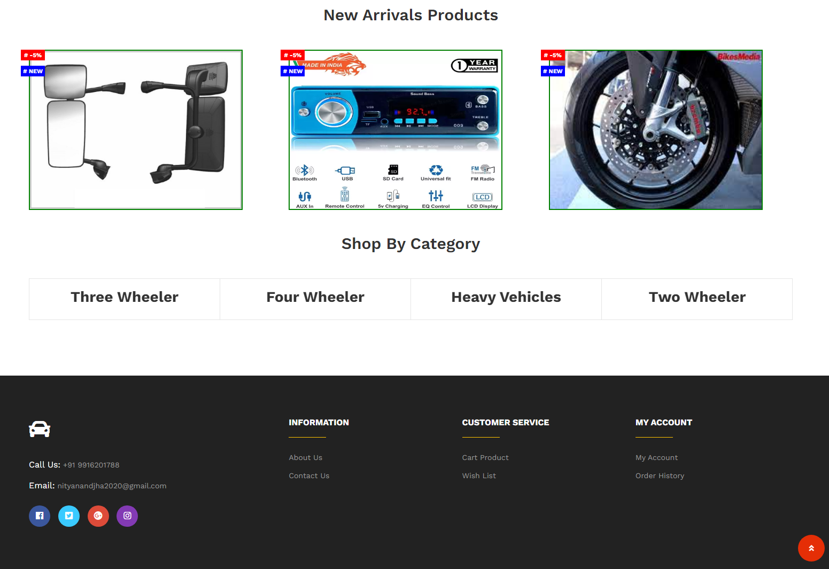

**Wish List Page:**

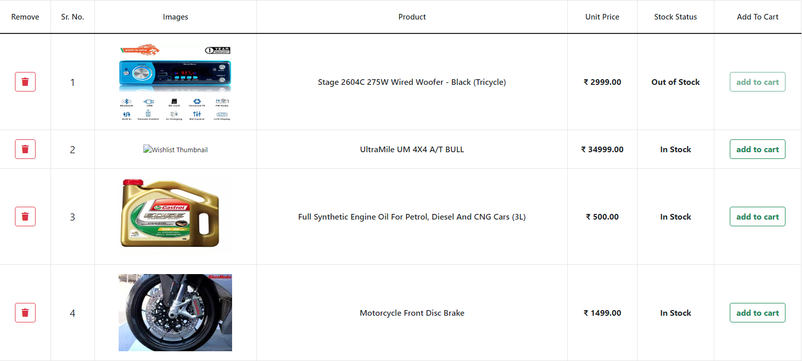

**Cart Product Page:**

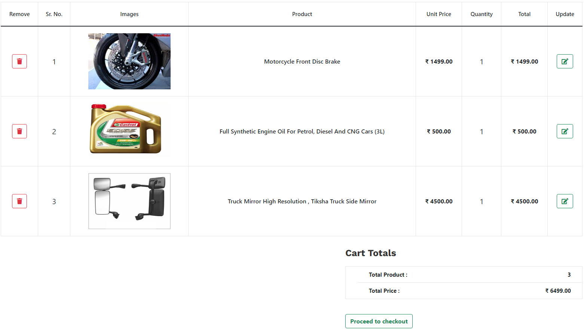

**Category Page:**

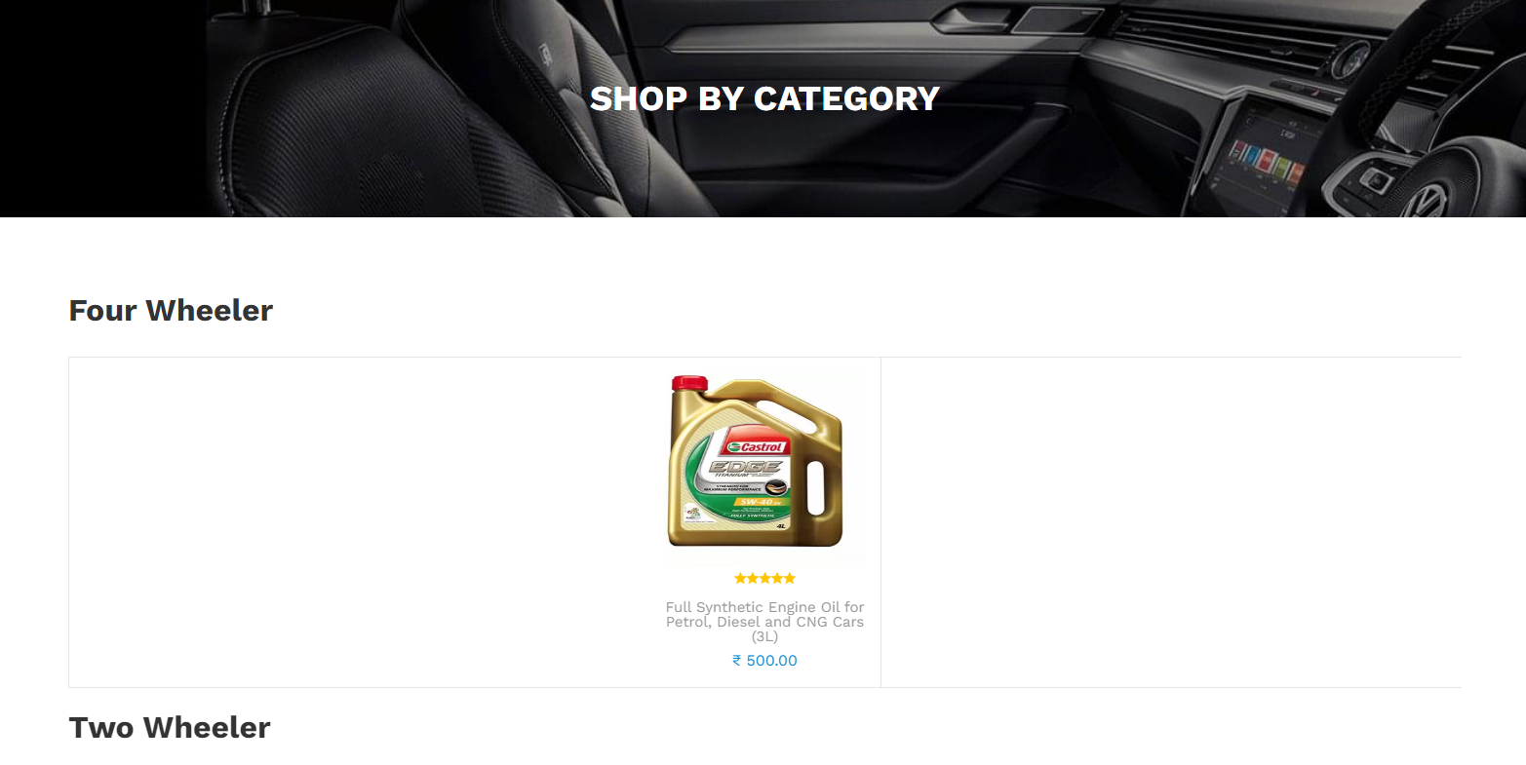

**Brands Page:**

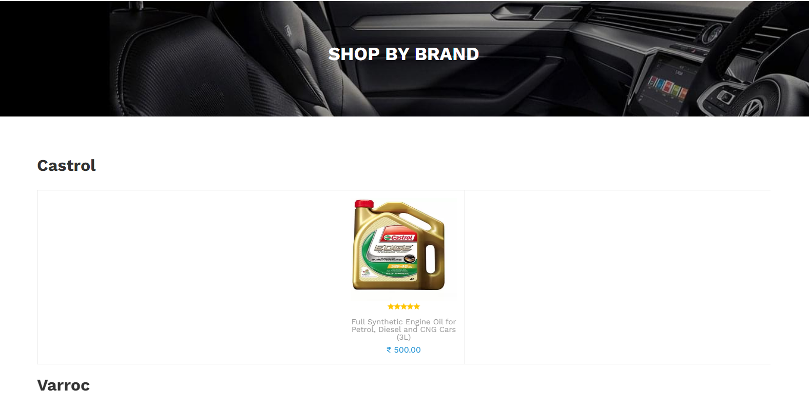

**User Profile Page:**

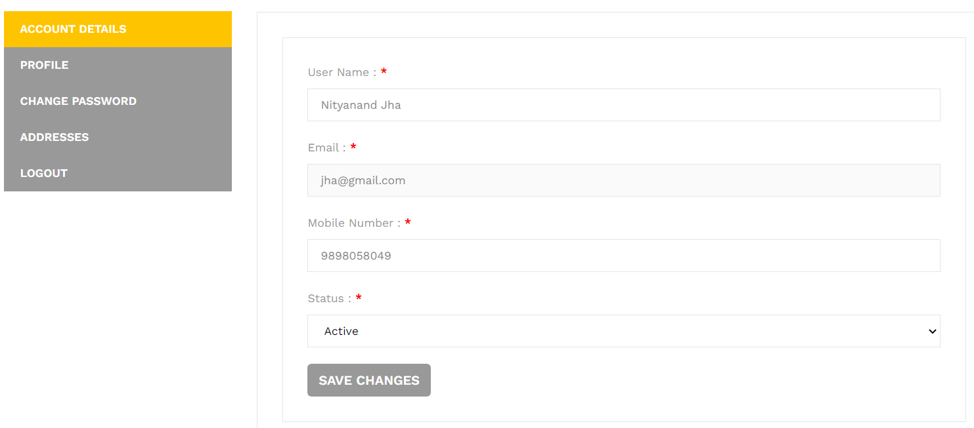

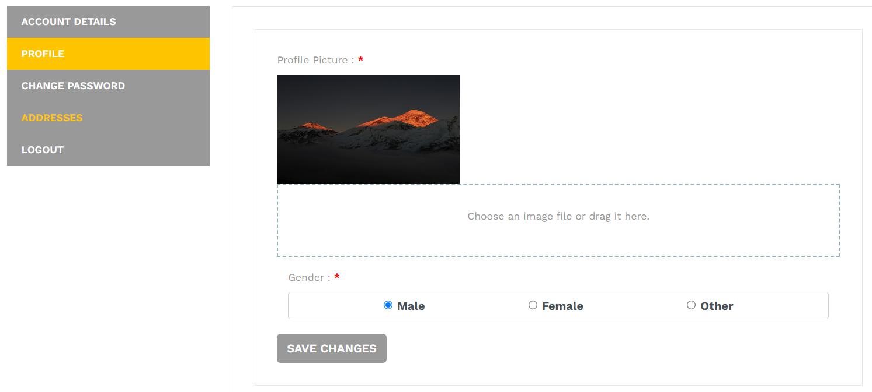

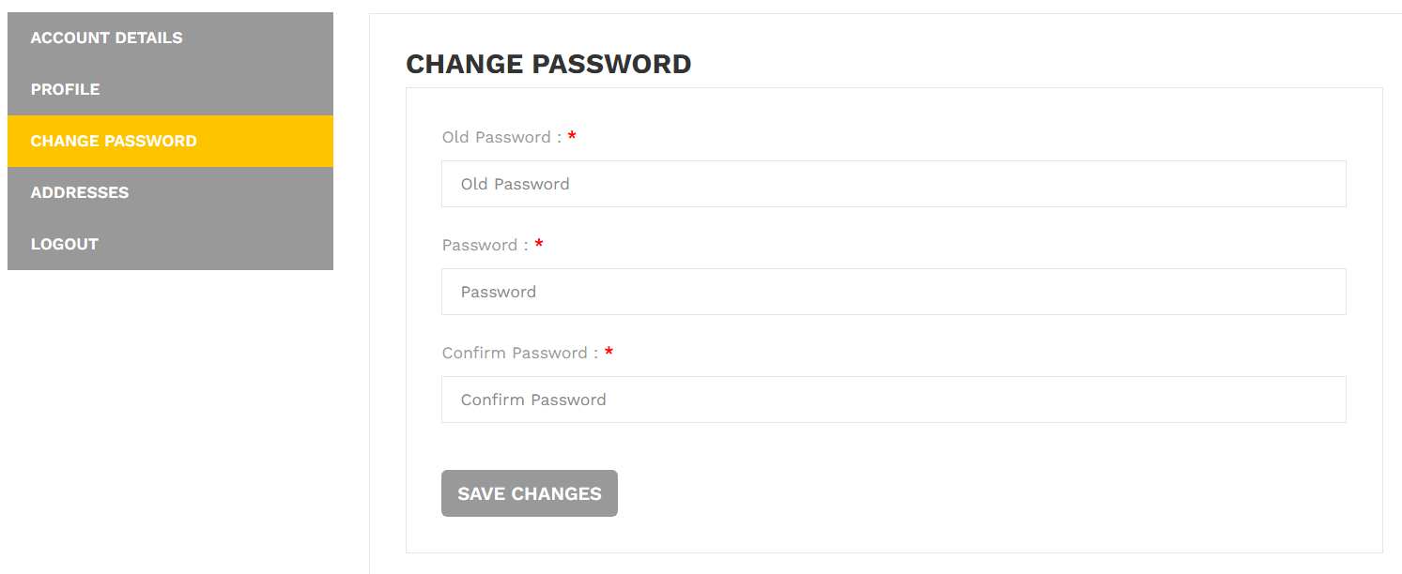

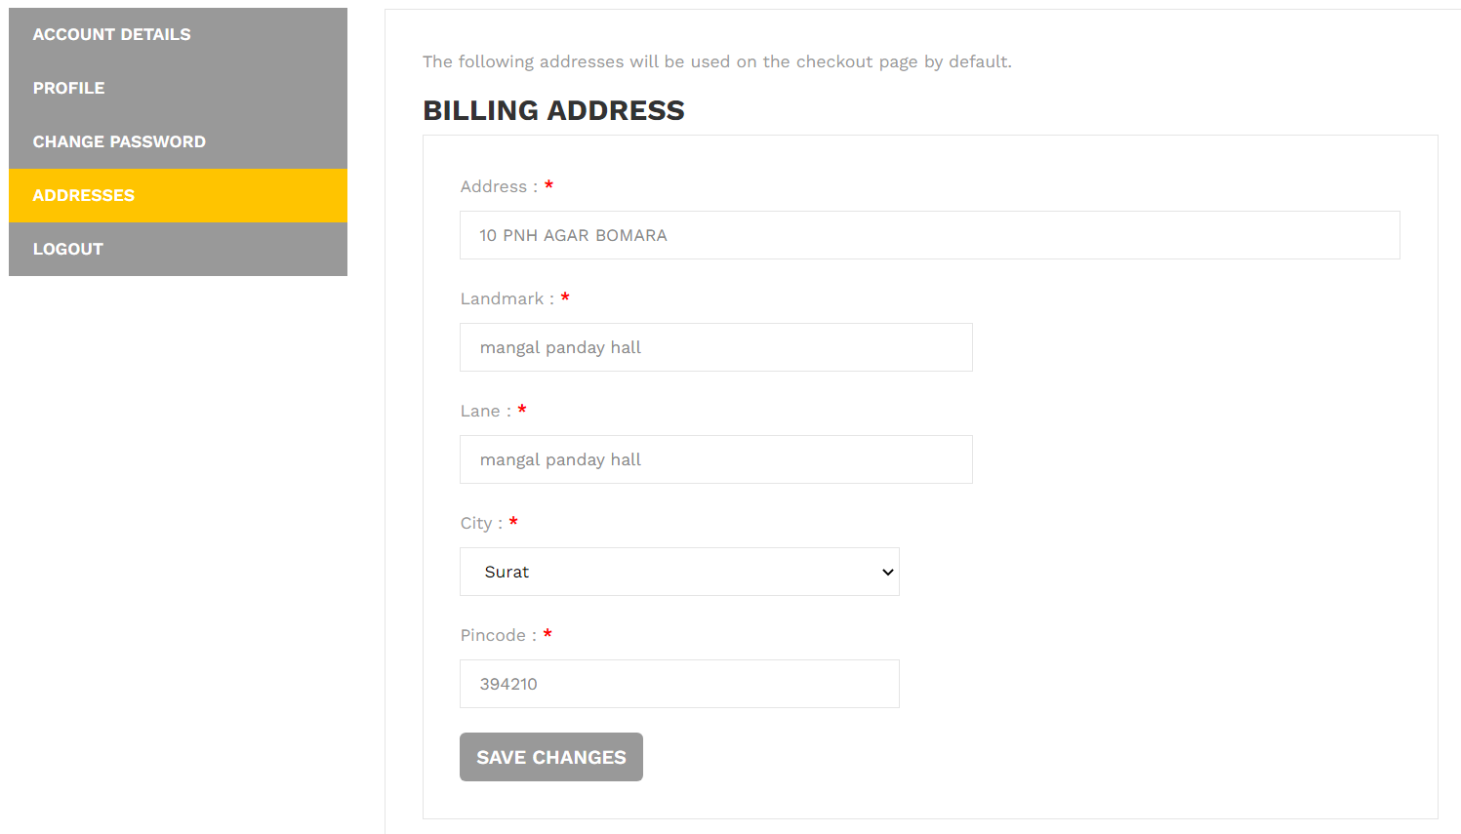

**Order Summary:**

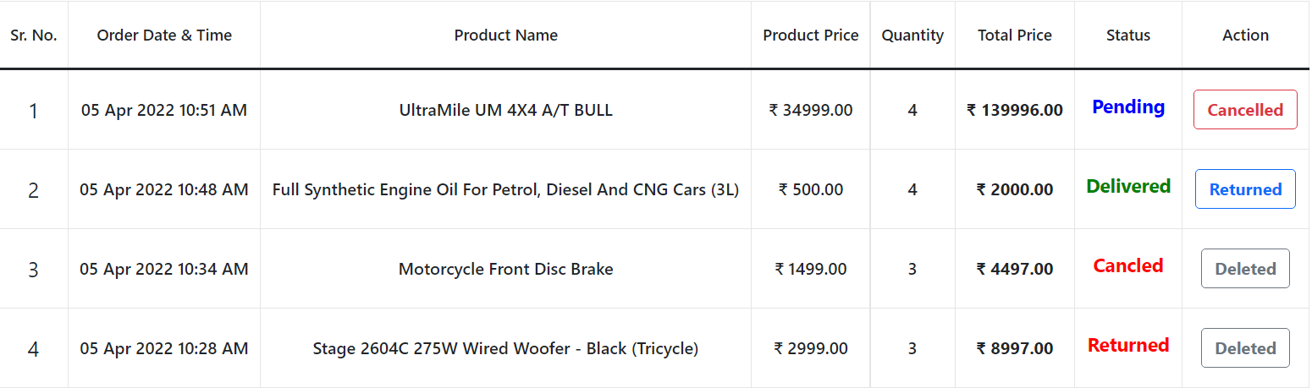

**Feedback Page:**

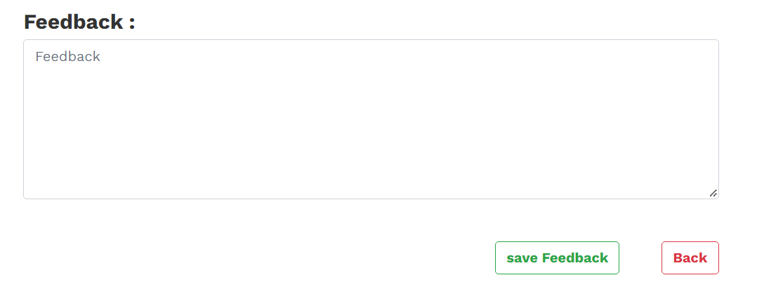

**About Us Page:**

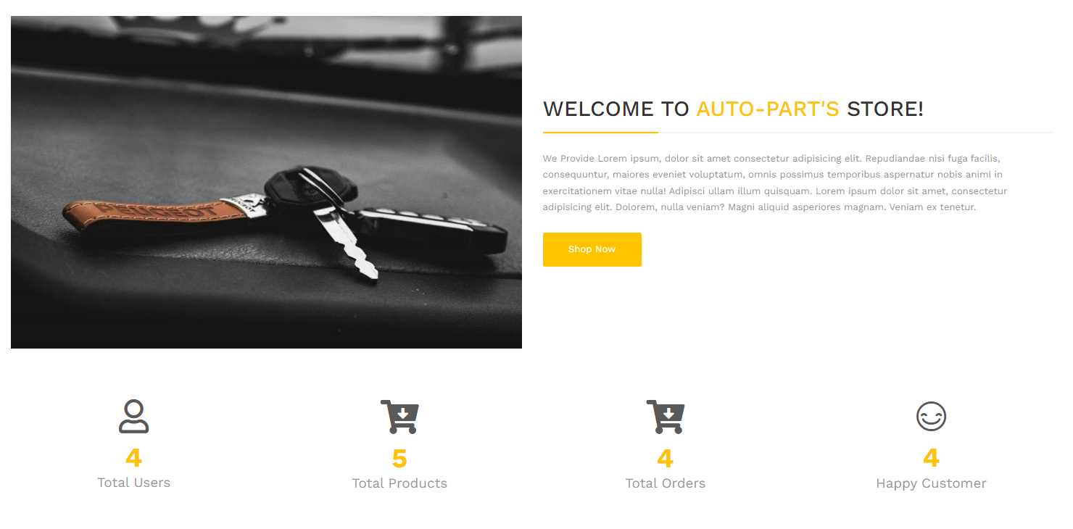

**Contact Us Page:**

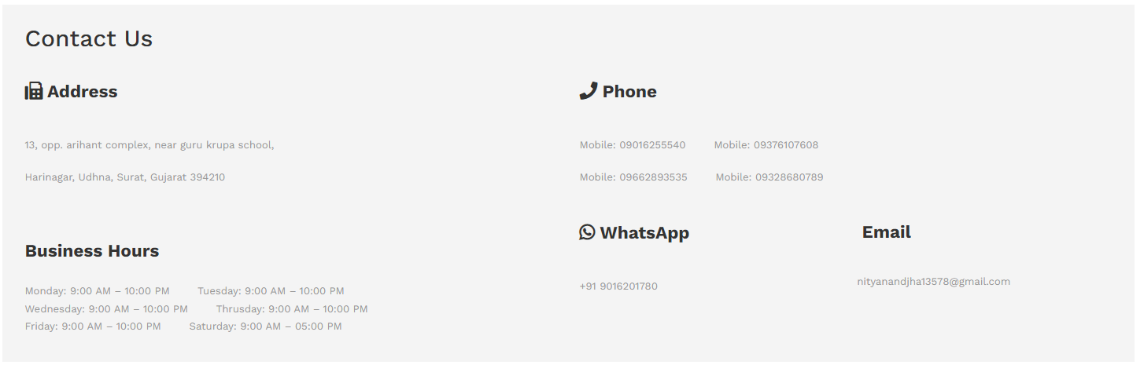

**Single Product Page:**

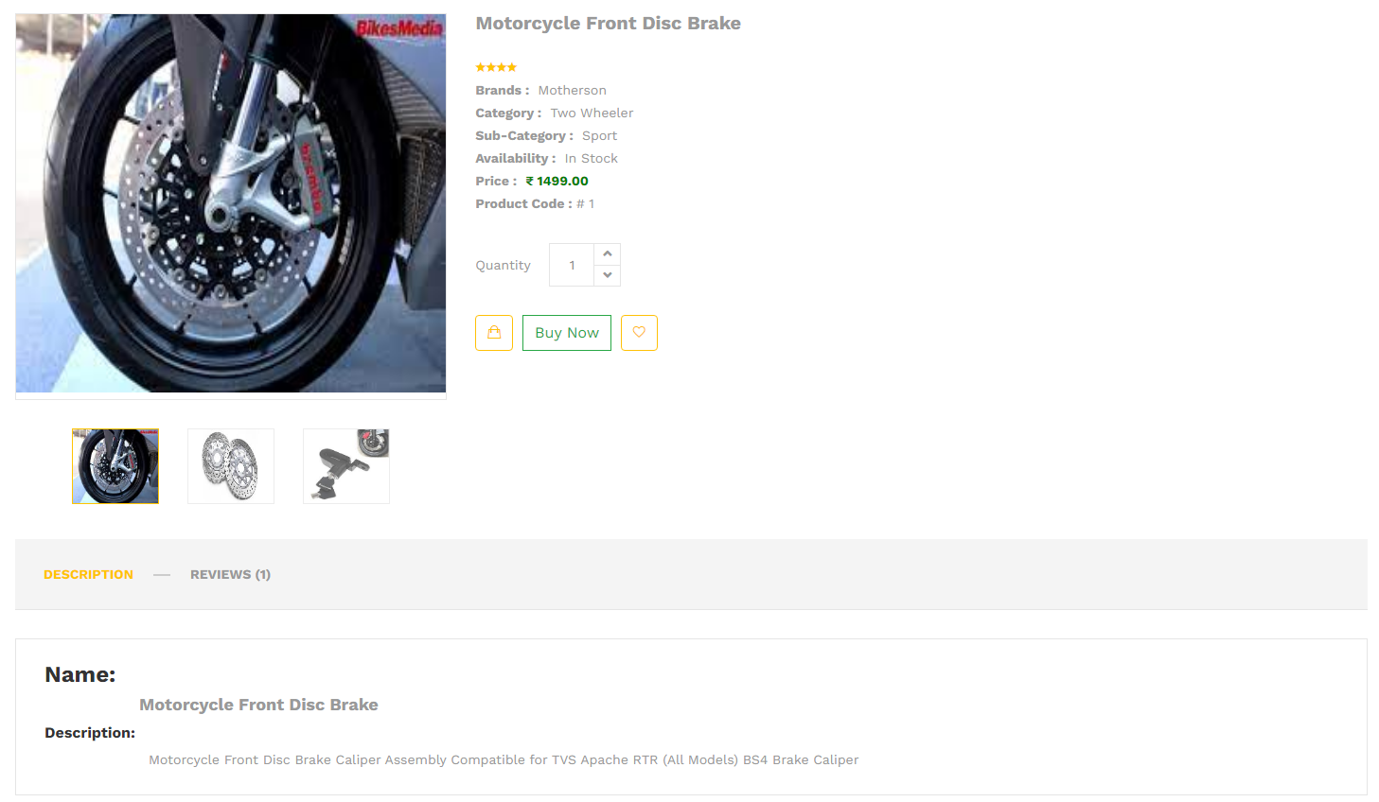

**Product Review:**

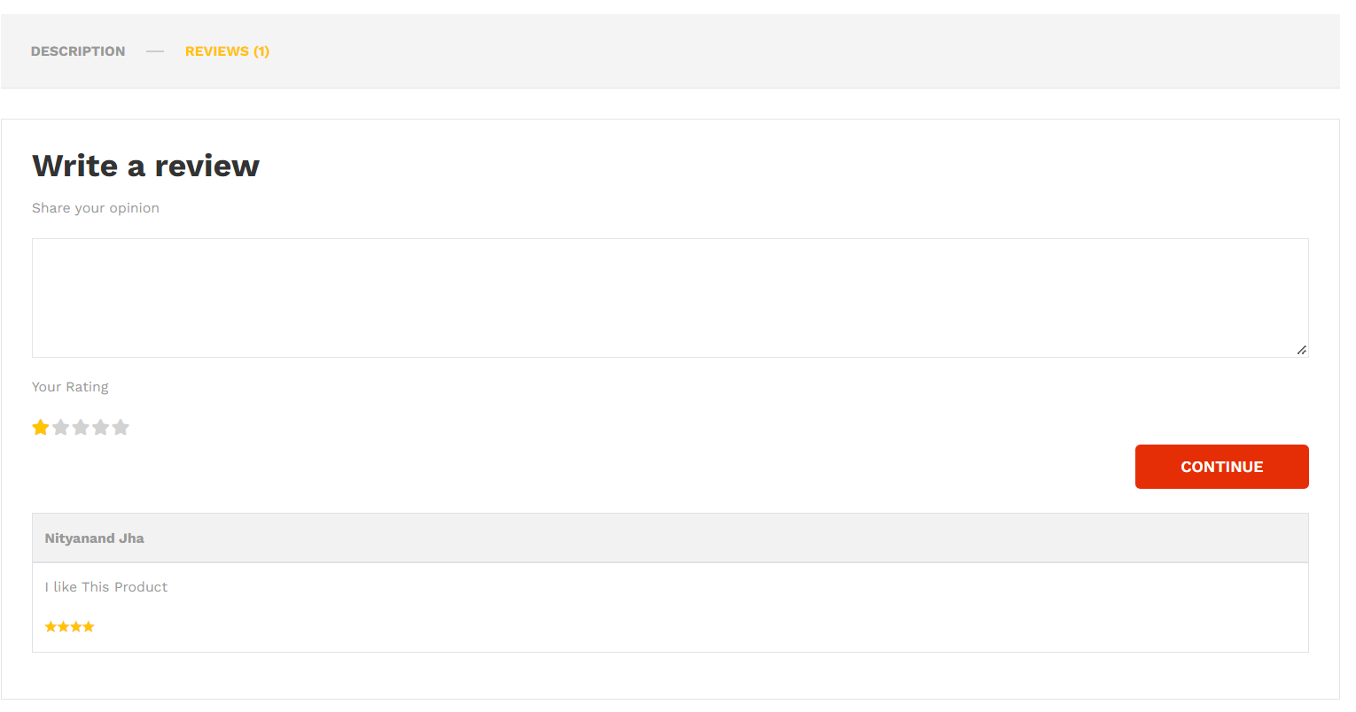

**Search Page:**

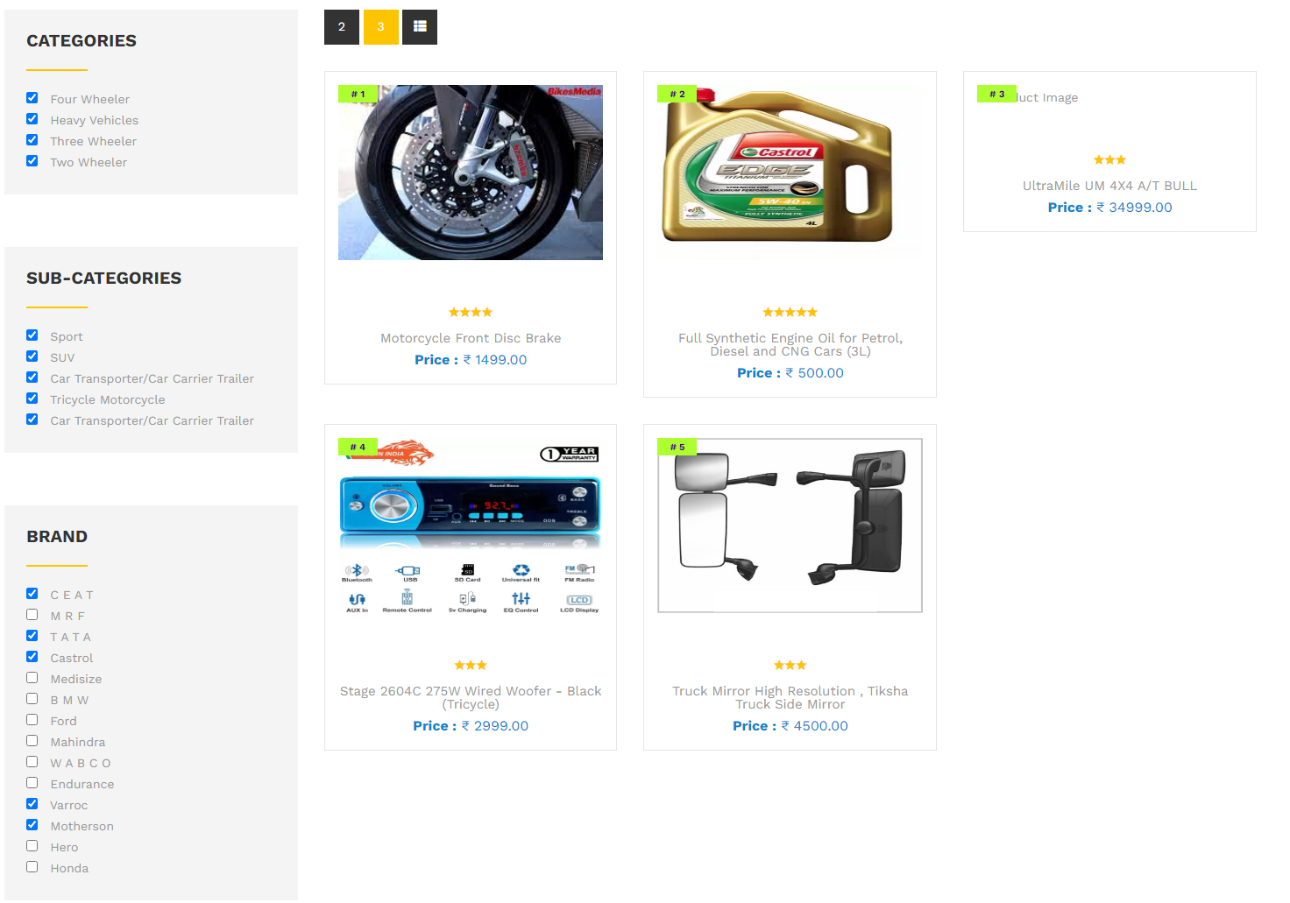

**Checkout Page:**

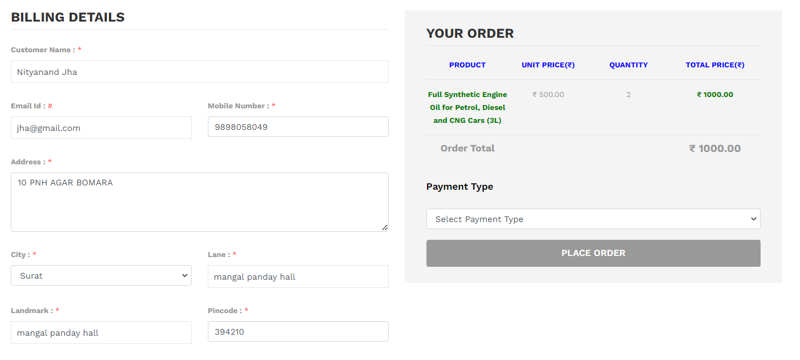

**6.3 System generated Reports**

A truly reliable system has many reports to fulfil user requirement to get require data from system.

***There can be different types of reports such as:***

1. Invoice.
2. All Product Reports.
3. All Order Reports.
4. All User Reports.
5. All Order Received Reports.
6. All Order Delivered Reports.
7. All Order Cancelled Reports.
8. All Order Returned Reports.
9. All Brand Reports.
10. Product In-Stock Reports.
11. Product Out-of-Stock Reports.

**1. Invoice Reports:**

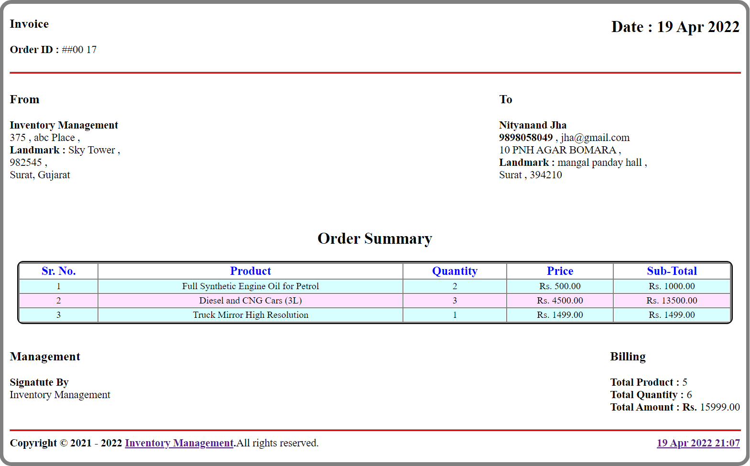

**2. All User Reports:**

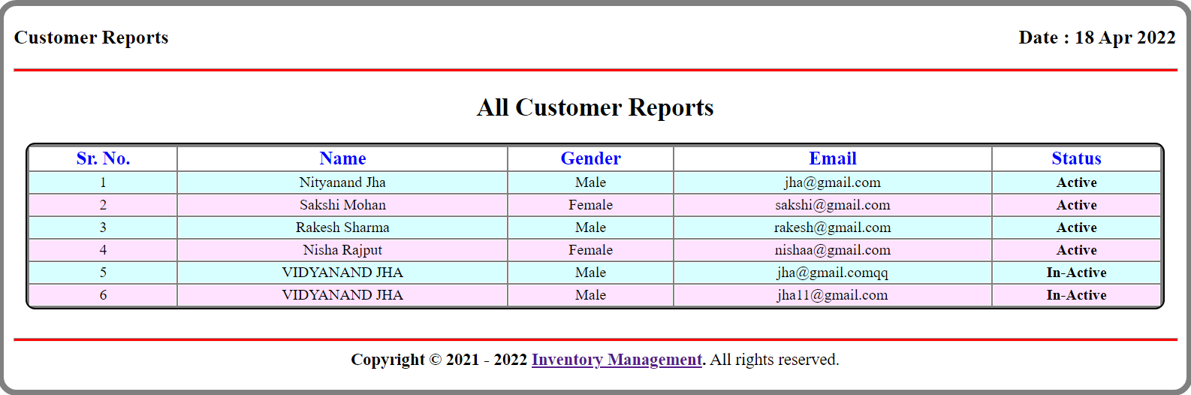

**3. All Product Reports:**

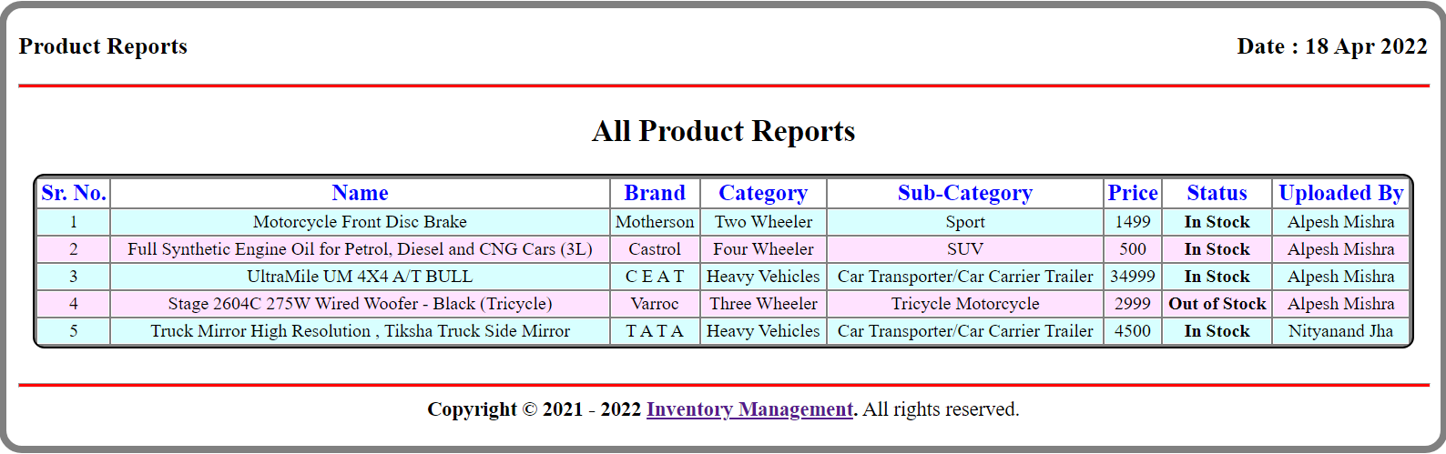

**4. All Order Reports:**

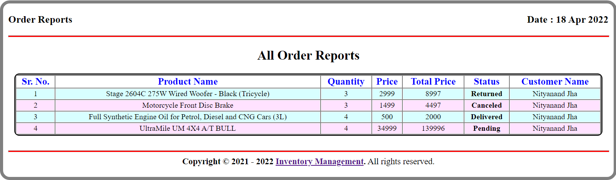

**5. Order Received Reports:**

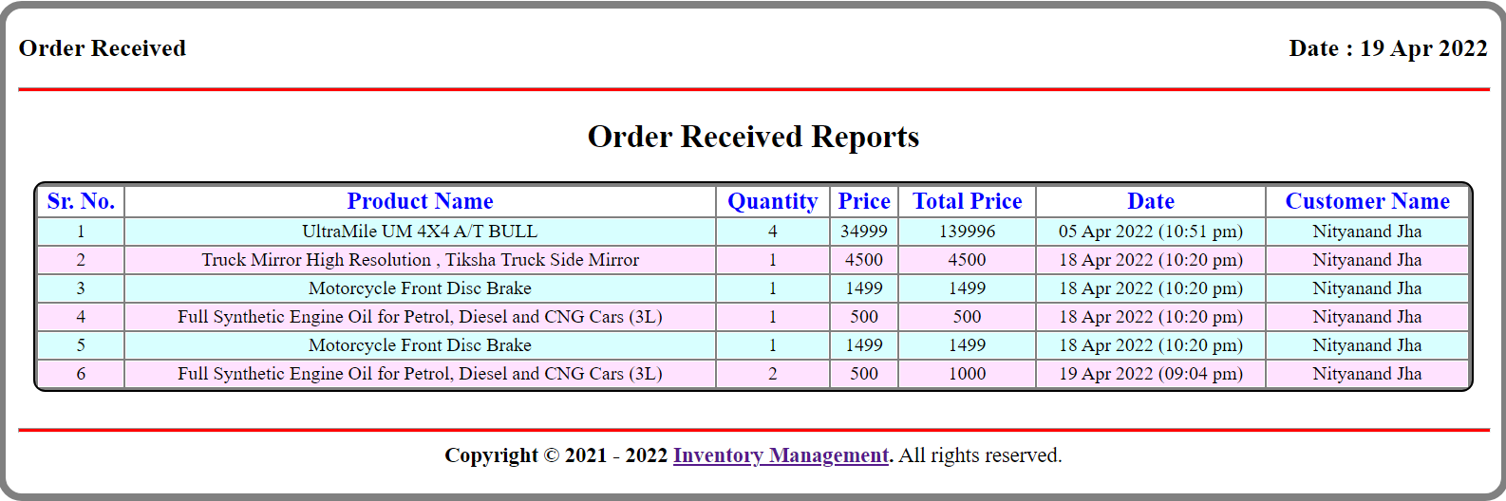

**6. Order Delivered Reports:**

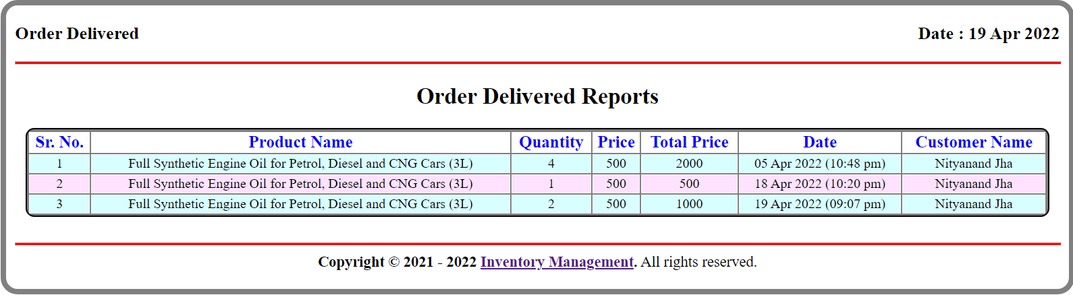

**7. Order Cancelled Reports:**

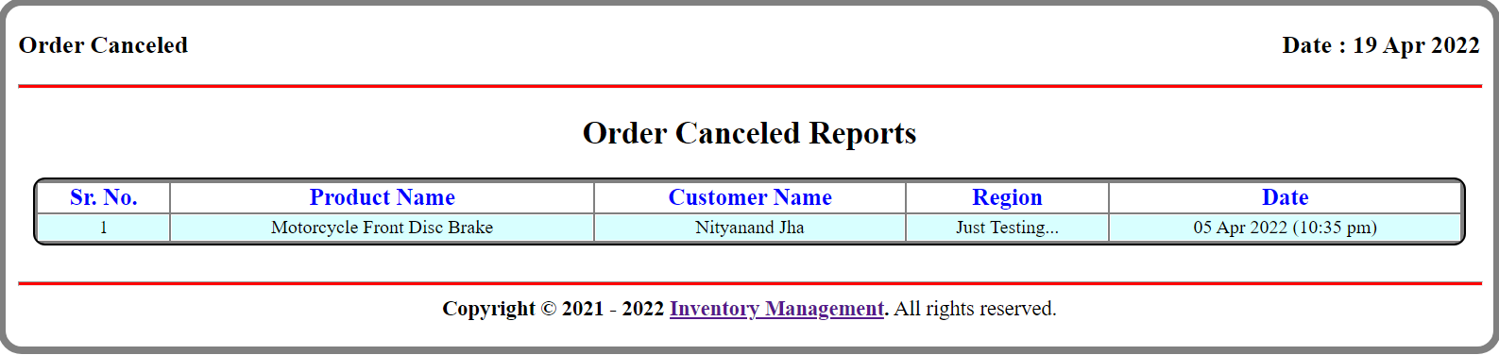

**8. Order Returned Reports:**

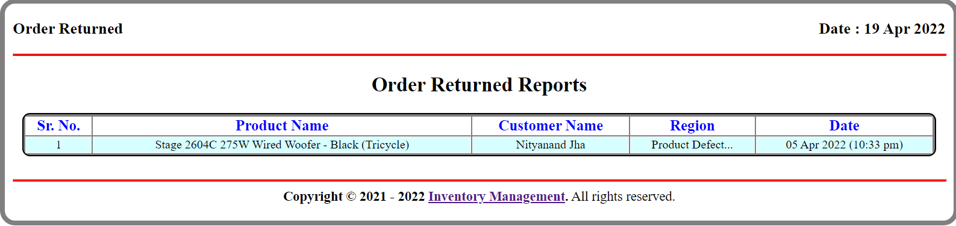

**9. All Brands Reports:**

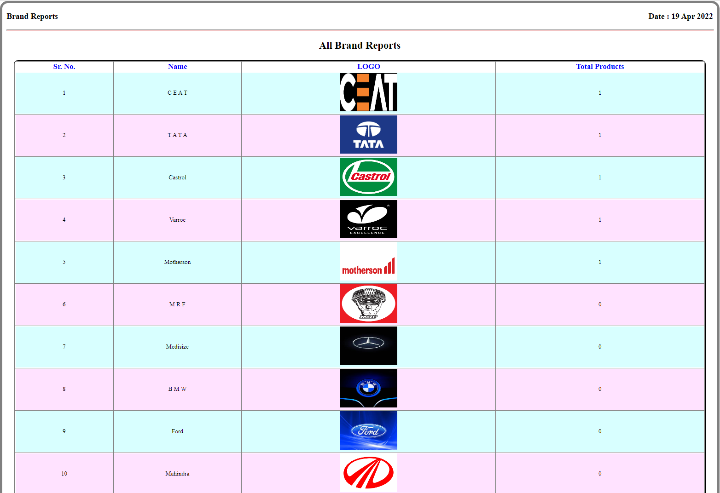

**10. Product In Stock Reports:**

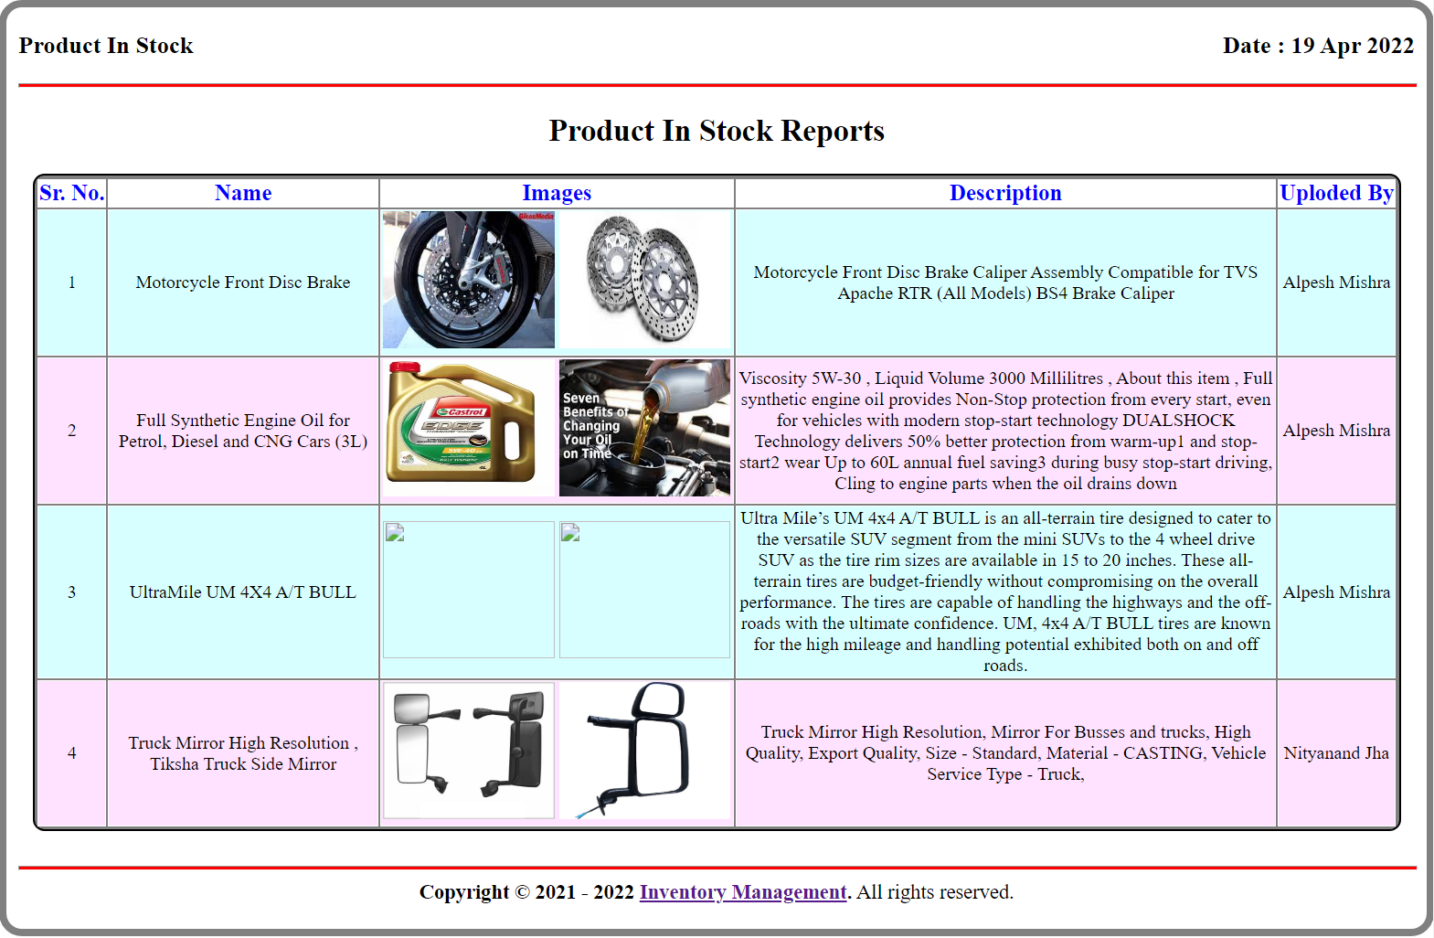

**11. Product Out of Stock Reports:**

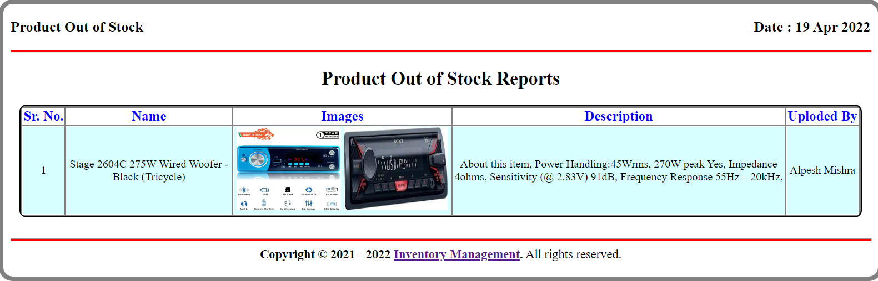

**Chapter – 7. Software Testing**

7.1 Test Cases & Test Data Design

7.2 Output Comparison

7.3 Testing Strategies

7.4 Unit Testing

7.5 Integration Testing

7.6 System Testing

7.7 Alpha Testing

**7.1 Test cases & Test Data Design**

I use many types of testing to improve the quality of my system and develop an acceptable system by the client. For the client satisfaction I do validation, verification and many more testing.

But implement all these testing first I should know how to develop the testing. Therefore, to improve the testing I use two important parts for testing.

**Test Case:**

Test Case is one kind of a formal discussion of predefine documentation at the analysis phase. It is not used as a practical testing. It is only a theoretical discussion. In this I discuses following:

1. **A Starting Stage:**

In which I discuss the requirements of customer and checks that all information which was define at analysis phase is full fill or not. I discusses all basis requirements related to Discussion is match with document or not.

1. **Event and Module to which Software must Response:**

Here I discuses that all events or modules which I developed, are accept the all inputs and data which user wants to puts and data which are useful for that module or not. In my system I checks that the inputted data for registration, service booking, and test drive booking are related to those entire event or not.

1. **Expected Output For Ending Stage:**

At this stage I do discuses about the expected output of the all events and modules. I check that all output and results are matched with all requirement of the client or not. In my system I discuss that Search modules, View Reports module, View User module, etc. produces the resultant output or not.

1. **Things which are useful for Test Cases:**

Analysis phase documentation is very useful when I preparing Test Case. My Online Discussion Forum System is Object Oriented so I used Data Flow Diagram for preparing Test Case.

**Test Data Design:**

Test Data is also a part of the developing the testing. Here I do not discuss any theoretical concept or topic. Here I performed many different testing as a practical form.

In test data, I generally used some validation and verification on data and check all these validation practically and match the constraints with documentation. I use test data in my system for check the all constrain related to my system like:

User’s Post Date is not less than User’s Registration Date

**7.2 Output Comparison**

With an integrated system that includes ERP, financials, commerce, inventory management, HR, PSA, supply chain management, CRM and more – NetSuite enables fast-growing businesses across all industries to work more effectively by automating core processes and providing real-time insights into operational and financial performance.

**7.3 Testing Strategies**

Testing strategies are very useful for performing the different types of testing in the system. It shows the way that how can we use different testing (unit testing, integration testing, validation testing, system testing) with the different phases of software engineering (Coding, Designing, Requirement, Whole system).

The software engineering process may be viewed as the spiral illustrated in Figure, system engineering defines the role of software and leads to software Requirements Analysis, where the information domain, function, behaviour, performance, Constraints and validation criteria for software are established.

A strategy for software testing may also be viewed in the context of the spiral. Unit testingbegins at the vortex of the spiral and concentrates on each unit (i.e., component) of the software as implemented in source code.

Testing progress is moving outward along the spiral to *integration testing,* where the focus is on design and the construction of the software architecture. Taking another turn outward on the Spiral, I encounter *validation testing,* where requirements established as part of Software requirements Analysis are validated against the software that has been constructed.

Finally, I arrive at system testing*,* where the software and other system elements are tested as a whole. To test computer software, I spiral out along streamlines that broaden the scope of testing with each turn.

**7.4 Unit Testing**

Unit testing focuses effort on the smallest unit of software component or module. Using the component-level design description as a Guide, important control paths are tested to uncover errors within the boundary of the module. The relative complexity of tests and uncovered errors is limited by the constrained scope established for unit testing. The unit test is white-box oriented, and the step can be conducted in parallel for multiple components.

***I performed Unit testing in my system to for test of small modules.***

Unit testing can performed from the bottom-up, Starting with smallest and lower level modules and proceeding one at a time, for each module in bottom-up testing a short program is used to execute the module and provide the needed data, so that module is asked to performed the way it will when embedded within the larger system.

With Unit testing I generally performed the white box testing in my all modules. In these all modules I check all coding and syntax of modules. So that unit testing is useful in my system.

**7.5 Integrated Testing**

Integration Testing is a systematic technique for constructing the program structure while at the same time conducting the tests to uncover errors associated with interfacing. In these I am combining all the Unit modules and test these all at the same time.

In my system I integrate all the modules and performed the integration testing on all those.

In my system, I used two techniques in Integration Testing:

**• Top down Integration:**

Combine the test and debug top level routines that become the integration test harness for low level units.

**• Bottom - Up Integration:**

***Bottom***-Up integration testing begins construction and testing with atomic modules. Because components are integrated from the bottom up, processing required for components subordinate to a given level is always available and the need for stubs is eliminated.

**A Bottom-Up integration strategy may be implemented with the following steps:**

1. Low-level components are combined into clusters that perform a specific software sub function.

2. A driver (a control program for testing) is written to coordinate test case input and output.

3. Drivers are removed and clusters are combined moving upward in the program structure.

**7.6 System Testing**

In this testing I take the requirements document as a reference to see whether the software meets all its requirements, goal or not. The objective of the system testing is to promote software functionality, reliability and maintainability.

System testing is used where the software and the other system elements are tested as a whole. Its comes at the top level of the testing which is done after completion of different sub testing such as unit testing, integration testing, validation testing. System testing is actually a series of different tests whose primary purpose is to fully exercise computer based system.

In these I use sub testing which verify that system elements have been integrated and performed allocated function or not.

I used some testing in my system such as:

**Recovery Testing:**

In this system testing I verify that if any failure occurred in my system then its recover proper or not.

**Security Testing:**

In this testing, I attempt to verify that protection mechanism of my system. In my system I check the security such as login and password security. If any user want to access system deep information and want to use system services then he/she must have to be login and other user can’t access or see the information of the another user.

**7.7 Alpha Testing**

Alpha testing is one of the most common system testing strategies used in system development. It’s specially used by product development organizations.

* This test takes place at the developer’s site. Developers observe the users and note problems.
* Alpha testing is testing of an application when development is about to complete. Minor design changes can still be made as a result of alpha testing.
* Alpha testing is typically performed by a group that is independent of the design team, but still within the company, e.g. in-house software test engineers, or software QA engineers.
* Alpha testing is final testing before the system is released to the general public. It has two phases:
* In the first phase of alpha testing, the system is tested by in-house developers. They use either debugger software, or hardware-assisted debuggers. The goal is to catch bugs quickly.
* In the second phase of alpha testing, the system is handed over to the system QA staff, for additional testing in an environment that is similar to the intended use.

Alpha testing is simulated or actual operational testing by potential users/customers or an independent test team at the developers’ site. Alpha testing is often employed for off-the-shelf software as a form of internal acceptance testing, before the system goes to beta testing.

**Chapter – 8. Software Implementation**

8.1 User Training

8.2 User Manual

**8.1 User Training**

User Training is designed to prepare the user for testing and converting the system. User involvement and training take place parallel with programming for ***three*** reasons:

1. The System group has time available to spend on training while the programs are being written.
2. Initiating a user training program gives the system group a clearer image of the user’s interest in the new system.
3. A trained user participates more effectively in the system testing.

The training programme should be planned & organized.

**Training Programmer should:**

1. Identify the user & trainer’s needs
2. Design a comprehensive training programmed.
3. Select the best method of instruction
4. Determine whether the system meet the objectives

**8.2 User Manual**

A user manual is a document provided to a user that helps in using a particular system, product or service seamlessly. It is also known as an instruction manual or a user guide. Such documents cover detailed information around operations, standards & guidelines, troubleshooting guides, functionalities & more.

User manuals are hugely important for users seeking to understand products and processes. Sometimes they will even be legally required for a company to sell its products to customers.

Customers will often turn to your user manual before reaching out to your customer support team, so your manual has the potential to save you money on support costs.

It’s worth investing significant time and effort in your user manual so you can provide the best customer experience possible. In this post, we’ll look at the definition of a user manual, best practices for how to write one, and some examples of software you can use to write your manual.

**Chapter – 9. Limitations / constraint**

Each and every system has some limitations that can restrict then to work on a particular environment.

Through my system is provided high amount of accuracy and quick data generation there is still some limitations that led me to in greater deficiency to work on that system.

***Some of the limitation that is observed during all the process is mentioned below.***

* GUI (Graphical User Interface) is required.
* We use PayPal system for money transaction so we cannot maintain user side Bank Account or Bank Related Information.

**Constraints:**

The constrains associated in the development of any software system include those that are common to all system and constrains specific to the system. The common constrains may include lack of managerial participation, tight development schedule, frequent change in requirements of the management, etc. we have also experience similar types of constraints listed above and others some of the constrains are listed below with which we have developed this system.

* It is a general system and hence there is unique from layout and format.
* Number of user depends on hosting environment and server configuration.

**Chapter – 10. Enhancement / Path-Ahead**

My System is efficient but still I can add another new feature in future as need arise means my system is flexible that if I needed in future I can increase or add that requirements to my system and can extend the work to my system.

**Chapter – 11. Bibliography / Appendix**

* <https://codewithmosh.com/> ( Tutor )
* <https://laravel.com/> (Framework)
* <https://www.amazon.in/> (Product Upload)
* <https://www.w3schools.in/> (For Code Testing)
* <https://stackoverflow.com/> ( For error Resolving )
* <https://github.com/valor-software/ng2-file-upload> ( third party library)
* https://adminlte.io/ (Admin Side Theme)
* <https://ng-bootstrap.github.io/> (Client Side theme)
* <https://getbootstrap.com/> (Use For Pop-up Model)
* <https://jquery.com/> (JQuery Library)

Thanking

You